During Language Arts we talked about making connections between the books we read with our personal experiences. This is called a text-to-self connection. Making connections improves reading comprehension.

We learned that good readers think about the sequence of events. As we read and reread books we pause to tell what happened at the beginning, middle, and end of the story. Throughout the year we will be making small books to show the beginning, middle, and end of stories. This will also help us to retell the story.

In class and in the library we discussed what makes a book either fiction (pretend) or non-fiction (real-life). We made an anchor chart to help us remember this.
Fiction is make-believe.
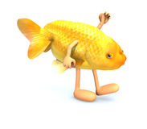
Non-fiction is real-life.
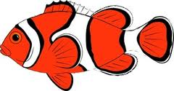

We learned the name and sound for the letters C,c and P,p. This week’s high-frequency words were the and and. We looked for them in books that we read and wrote sentences using the words.

I like the _____ and the _____.

* * * * * * * * * * * * * * * * *
In math we worked on counting objects accurately and discussed why this is important.
We identified and described the circle, square, triangle, and rectangle. We had fun singing the Shape Hokey Pokey song. We practiced counting forward to 100 and back from 10.
In Social Studies we are learning why rules are important. We talked about some rules at school and compared them to rules at home. We are learning what it means to be a good citizen.

In science we correctly labeled parts of a tree to show our learning (roots, trunk, branches, and leaves).

After tasting red, yellow, and green apples, we created a graph to record which kind of apple people liked best. Yum!
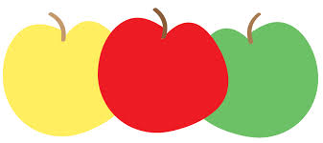

Dates to Remember:
Friday, October 6th
Field trip permissions slips
& money due

Sunday, October 8th
PTO Color-a-thon

Friday, October 13th
Spirit Day (Wear Jeffery colors, popcorn is 50 cents/bag)

Friday, October 20th
Fall Fest 5:30-8:00 pm

Wed-Fri, October 25-27
Parent-Teacher Conferences

Please send a class snack for October next week.

Have a wonderful weekend!

Sunday | Monday | Tuesday | Wednesday | Thursday | Friday | Saturday

1 | 2 | 3 | 4 | 5 | 6 | 7

 | P.A.L.S. Phonological Awareness Literacy Screener |  |  |  | Permission  slips &  money due
8 | 9 | 10 | 11 | 12 | 13 | 14
PTO  Color-a-Thon  at Jeffery |  |  |  |  | Popcorn &  Spirit Day  50 cents/bag
15 | 16 | 17 | 18 | 19 | 20 | 21
 | Jerry Smith  Pumpkin  Farm  field trip |  |  |  | Jeffery PTO  Fall Fest  5:30-8:00pm
22 | 23 | 24 | 25 | 26 | 27 | 28
 |  |  | Full day for  students  Parent-Teacher  Conferences | Half day for students  11:15 dismissal  Parent-Teacher  Conferences | No School  for students  Parent-Teacher  Conferences
29 | 30 | 31 | 1 | 2 | 3 | 4
 |  |  |  | End of  1st Quarter | No School  for students  Staff  Work Day

