This week we learned the letters F,f N,n, Bb, and Ii. The alphafriends were Fifi Fish, Nyle Noodle, Benny Bear, and Iggy Iguana. Our high-frequency words were the and and. We searched in books for these words. We talked about the importance of spaces between words when we read and write. We practiced counting the number of words in some sentences.

Your child should be able to identify the following words:

I like the and

* * * * * * * * * * * * * * * * *
Throughout the week we have opportunities to practice independent reading. Our goal is to build stamina to be able to Read-to-Self for several minutes uninterrupted.
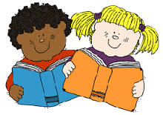

We learned that good readers think about the sequence of events. As we read and reread books we pause to tell what happened at the beginning, middle, and end of the story. Throughout the year we will be making small books to show the beginning, middle, and end of stories. This will also help us to retell the story.

In class and in the library we discussed what makes a book either fiction (pretend) or non-fiction (real-life).

In Math we practiced writing numbers correctly.
We also worked on putting the numbers 0-15 in order. We learned about sorting objects by their attributes (large, small, thick, thin). Some of us sorted the objects by color and others sorted by shape.

In Social Studies we are learning why rules are important. We talked about some rules at school and compared them to rules at home. We are learning what it means to be a good citizen.

Your child is bringing home a Pizza Hut Book-It sheet to keep track of 12 books read during the month. When the sheet is returned by the end of the month your child will receive a coupon for a free personal pan pizza. The Book-It program runs October through March.

If you have not already, please return the permission slip and money for the field trip to Borzynski’s Farm. Thank you
Dates to Remember:
Friday, October 12th
Spirit Day (Wear Jeffery colors, popcorn is 50 cents/bag)

Friday, October 19th
Fall Fest 5:30-8:00 pm

Wed-Fri, October 24th-26th
Parent-Teacher Conferences

Please send a class snack for October next week.
Have a wonderful weekend!

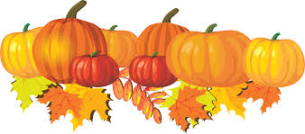
Sunday | Monday | Tuesday | Wednesday | Thursday | Friday | Saturday
 | 1 | 2 | 3 | 4 | 5 | 6
7 | 8 | 9 | 10 | 11 | 12 | 13
Popcorn &
Spirit Day
(Popcorn 50¢/bag)

14 | 15 | 16 | 17 | 18 | 19 | 20
 |  | Field Trip |  |  | Jeffery PTO  Fall Fest  5:30-8:00 pm
21 | 22 | 23 | 24 | 25 | 26 | 27
 |  |  | Student hours  7:25-2:25  Parent-Teacher  Conferences  3:10-6:10 pm | Student hours  7:25-11:15 am  Parent-Teacher  Conferences  12:10-3:10 pm  5:00-7:00 pm | (NO school  for students)  Parent-Teacher  Conferences  7:10-9:10 am
28 | 29 | 30 | 31

PALS Assessment

