We have been reading books by author Kevin Henkes which include Chrysanthemum, Sheila Rae the Brave, and Lily’s Purple Plastic Purse. We learned that good readers think about the sequence of events. As we read and reread books we pause to tell what happened at the beginning, middle, and end of the story. Throughout the year we will be making small books to show the beginning, middle, and end of stories. This will also help us retell the story.

In class and in the library we discussed what makes a book either fiction or non-fiction. We made an anchor chart to help us remember this.
Fiction is make-believe.
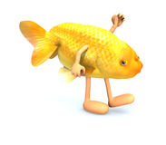
Non-fiction is real-life.
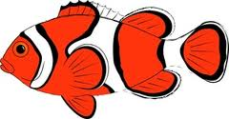

We learned the name and sound for the letters C,c and P,p. The high-frequency word was and. In our journals we wrote sentences about things we like.

I like the _____ and the _____.

* * * * * * * * * * * * * * * * *
In math we worked on counting objects accurately and discussed why this is important.
We identified and described the circle, square, triangle, and rectangle. We had fun singing the Shape Hokey Pokey song. We practiced counting forward to 100 and back from 10.

* * * * * * * * * * * * * * * * *
We read books and learned about Johnny Appleseed. We correctly labeled parts of a tree to show our learning.

We did apple tasting and made a graph to show the results. Next week we will be making applesauce!
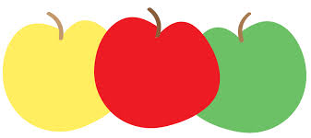

Dates to Remember:

October 5th
Kindergarten field trip to Apple Holler

Friday, October 9th
Spirit Day (Wear Jeffery colors, popcorn is 50 cents/bag)

Friday, October 16th
Fall Fest 5:30-8:00 pm

Wed-Fri, October 21-23rd
Parent-Teacher Conferences

Please send a class snack for October next week.

Have a wonderful weekend!

Mrs. Duford
mduford@kusd.edu

Mrs. Warren
rewarren@kusd.edu

If you have not already, please return the permission slip and money for the Apple Holler field trip. Thank you.
Sunday | Monday | Tuesday | Wednesday | Thursday | Friday | Saturday

20 | 21 | 22 | 23 | 24 | 25 | 26

Picture Day

Color Run
Packets due
27 | 28 | 29 | 30 | October 1 | 2 | 3
4 | 5 | 6 | 7 | 8 | 9 | 10
 | Kindergarten  Apple Holler  field trip |  |  |  | Popcorn &  Spirit Day  50 cents/bag
11 | 12 | 13 | 14 | 15 | 16 | 17
PTO
Color Run
at Jeffery

18 | 19 | 20 | 21 | 22 | 23 | 24
 |  |  | Full day for  students  Parent-Teacher  Conferences | Half day for students  11:15 dismissal  Parent-Teacher  Conferences | No School  for students  Parent-Teacher  Conferences

