We have been reading books by author Kevin Henkes which include Chrysanthemum, Sheila Rae the Brave, and Lily’s Purple Plastic Purse. We learned that good readers think about the sequence of events. As we read and reread books we pause to tell what happened at the beginning, middle, and end of the story. Throughout the year we will be making small books to show the beginning, middle, and end of stories. This will also help us retell the story.

In class and in the library we discussed what makes a book either fiction or non-fiction. We made an anchor chart to help us remember this.
Fiction is make-believe.
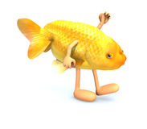
Non-fiction is real-life.
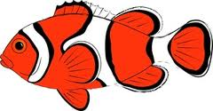

During Language Arts we talked about making connections between the books we read with our personal lives. This is called a text-to-self connection. Making connections improves reading comprehension.

We learned the name and sound for the letters C,c and P,p. This week’s high-frequency words were the and and. We looked for them in books that we read and wrote sentences in our journals using the words.
.
I like the _____ and the _____.

* * * * * * * * * * * * * * * * *
In math we worked on counting objects accurately and discussed why this is important.
We identified and described the circle, square, triangle, and rectangle. We had fun singing the Shape Hokey Pokey song. We practiced counting forward to 100 and back from 10.

* * * * * * * * * * * * * * * * *
In Social Studies we are learning why rules are important. We talked about some rules at school and compared them to rules at home.

In science we correctly labeled parts of a tree to show our learning (roots, trunk, branches, leaves).

After tasting red, yellow, and green apples, we created a graph to record which kind of apple people liked best.
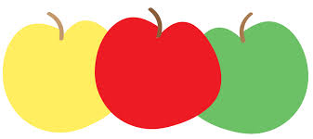

Dates to Remember:
Friday, October 14th
Spirit Day (Wear Jeffery colors, popcorn is 50 cents/bag)

Sunday, October 16th
Color Run

Friday, October 21st
Fall Fest 5:30-8:00 pm

Wed-Fri, October 21-23rd
Parent-Teacher Conferences

Please send a class snack for October next week.

Have a wonderful weekend!

Sunday | Monday | Tuesday | Wednesday | Thursday | Friday | Saturday

25 | 26 | 27 | 28 | 29 | 30 | 1

2 | 3 | 4 | 5 | 6 | 7 | 8
9 | 10 | 11 | 12 | 13 | 14 | 15
Popcorn &
Spirit Day
50 cents/bag
16 | 17 | 18 | 19 | 21 | 21 | 22
PTO  Color Run  at Jeffery |  |  |  |  | Jeffery PTO  Fall Fest  5:30-8:00 pm
23 | 24 | 25 | 26 | 27 | 28 | 29
 |  |  | Full day for  students  Parent-Teacher  Conferences | Half day for students  11:15 dismissal  Parent-Teacher  Conferences | No School  for students  Parent-Teacher  Conferences

