In reading we are listening for words that rhyme by reciting several nursery rhymes. Before reading a book we find the front cover, back cover, and title page. Ask your child to show you the title page the next time you read a book together.

Each week in the library the students are expected to choose one fiction and one non-fiction book. They get to decide which one goes home and which one stays at school to be kept in their browsing box/book bin.

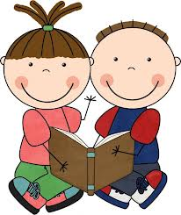

* * * * * * * * * * * * * * * * * * * *
This week we met the Alphafriends Andy Apple, Tiggy Tiger, Pippa Pig, and Callie Cat. We listened to their songs and looked at pictures beginning with their sounds. By using the letters m, s, a, t, p, c we made the words at, mat, sat, pat, cat, cap, map, sap, tap.

We learned the words I and like. We looked for them in books that we read.

During Language Arts we talked about making connections between the books we read with our personal lives. This is called a text-to-self connection.

* * * * * * * * * * * * * * * * * * * *
In Math we are using the computer program IXL. Currently we are doing this as a class in front of the Promethean board. Each student has been assigned a username and password to be used in the computer lab and at home.
In science we will be learning what scientists do. As scientists, we will make predictions, investigate, record, and communicate our findings.

* * * * * * * * * * * * * * * * * * * *
Please send two apples to school next week. We will be tasting
apples and making a graph.
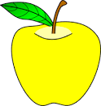
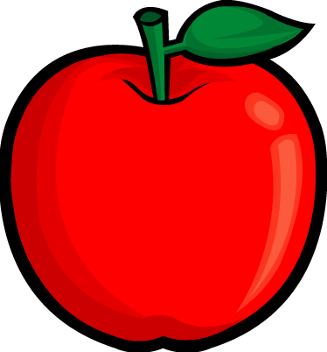

Some of the apples will also be used to make applesauce.

Dates to Remember:

Friday, October 12th
Spirit/Popcorn Day

Friday, October 19th
Fall Fest

Don’t forget about the
Popcorn Pass ($4) and the
Fall Fest wristband ($11).

Information was sent home from the PTO regarding both activities.

Have a wonderful weekend!

