In reading we are listening for words that rhyme by reciting several nursery rhymes. Before reading a book we find the front and back cover and the title page. Ask your child to show you the title page the next time you read a book together.

During Language Arts we practiced the
Three Ways to Read a Book:

- Read the pictures.
- Read the words.
- Retell the story.

Each week in the library the students are expected to choose one fiction and one non-fiction book. They get to decide which one goes home and which one stays at school to be kept in their browsing box/book bin.

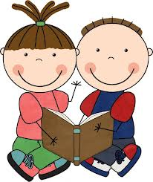

* * * * * * * * * * * * * * * * * * * *
This week we met the Alphafriends Andy Apple and Tiggy Tiger. We listened to their songs and looked at pictures beginning with their sounds. By using the letters m,s,a,& t we made the words at, mat, sat.

This week we learned the words I and like. We read a book and each of us got to tell about something we like. Then we wrote sentences in our journals using the words.

I like _______.

In Math we are using the computer program IXL. Currently we are doing this as a class in front of the Promethean board. Each student has been assigned a username and password to be used in the computer lab and at home.

* * * * * * * * * * * * * * * * * * * *
In science we are learning about trees. We went outside and sat under the tree in front of the school. We drew a picture of how the tree looks now. Each season we will draw the tree to notice how it has changed. We will be making tree booklets to show the parts of a tree, also. Over the next few weeks we will learn the functions of the various parts of trees.

* * * * * * * * * * * * * * * * * * * *

Please send two apples to school next week. We will be tasting apples and making a graph.

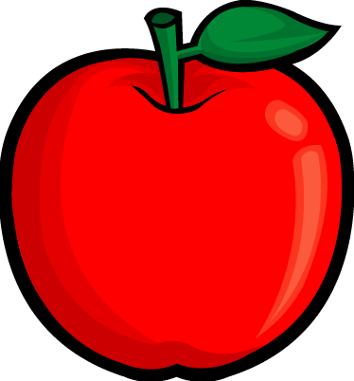

Some of the apples will also be used to make applesauce.

Dates to Remember:
Monday, September 19th
Picture Day
Color-a-thon Packets due

Friday, October 14th
Spirit/Popcorn Day

Have a wonderful weekend!

