Language Arts: We’ve been learning the alphabet as we learn our classmates’ names. We sorted pictures beginning with the same letter sounds. We talked about three ways to read a book:
- Look at the pictures.
- Read the words.
- Retell the story.

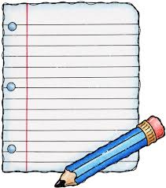
We are working on
writing our first
names using only
a capital letter at
the beginning and
the rest of the
letters lowercase.

Math: KUSD has a new math program called Bridges. This week we worked on counting objects with five-frames and ten-frames. We learned poems as we practiced writing numbers. We compared attributes of classmates’ shoes and created a graph.
At the end of each math lesson we do Work Place activities. Currently we are working with Unifix cubes, pattern blocks, polydrons, coins with counting mats, and geoboards.

Science: We are learning about the needs of plants and animals. When presented with a question we will do investigations to help us learn and problem solve together.

Social Studies: We compared and contrasted rules at home and rules at school.

The kindergarten classes will be going on a field trip to Green Meadows Farm on Wednesday, October 9th. The permission slip will be sent home next week. Chaperones must have a criminal background check on file in the office in order to chaperone.
Picture Day
Monday, September 16
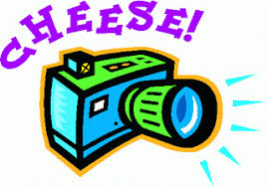

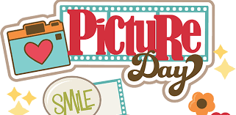

Dates to Remember:

Monday, September 16th
Picture Day

Monday, September 30th
Bridges Family Math Night
(5:30 dinner, 6:00 program)

Wednesday, October 9th
Green Meadows Field Trip

Friday, October 11th
Spirit & Popcorn Day

Friday, October 18th
PTO Fall Fest (5:30-8:00 pm)

Have a wonderful weekend!

