This week’s high-frequency words were went and by. We listed words with the -ake spelling pattern. We sorted –ate and –ake pictures and words.

We read different versions of The Little Red Hen. We compared & contrasted the characters and events in the stories. We especially liked The Little Red Hen Makes a Pizza.
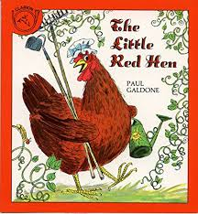
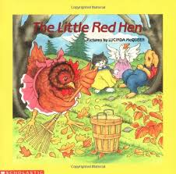

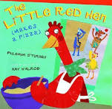

During writer’s workshop we talked about adding details and describing words (adjectives) to our sentences. Words that tell color, size, shape, amount, texture, etc. help the writer create more vivid descriptions for their story.

In math we wrote pairs of numbers and discussed which number is greater? Why?
We concluded that the number with the largest digit in the tens place is the greater number.

24 42 37 73

During social studies we are learning about families, culture, and traditions. We talked about special things we do with our families. We looked at pictures of families and the way they celebrate their special events.

In science we did an investigation to see the effect that sunlight has on various surfaces. We used a heat lamp as our source of light. We checked the temperature of a piece of black rubber without the lamp on and then with the lamp on. The rubber surface got a lot hotter with the lamp on.

We candled an egg and could see the air sac, blood vessels, and developing chick inside! The eggs have been incubating for one week.

Mark your Calendar:
- Our Green Meadows Farm field trip has been rescheduled. We are sorry for the inconvenience. A new permissions slip will be sent home on Monday. The new date will be Wednesday, June 6th.

The kindergarten music program is scheduled for Tuesday, May 29th,
at 6:00 p.m.

Have a wonderful weekend!

Please see other side for calendar
Sunday | Monday | Tuesday | Wednesday | Thursday | Friday | Saturday
6 | 7 | 8 | 9 | 10 | 11 | 12
 |  | PTO meeting  6:00 pm  in library |  |  | Spirit &  Popcorn  Day
13 | 14 | 15 | 16 | 17 | 18 | 19
20 | 21 | 22 | 23 | 24 | 25 | 26
27 | 28 | 29 | 30 | 31 | June 1 | 2
 |  | Kgn Music  Program  6:00 pm |  |  | Ice Cream  Social  5:30-8:00 pm
3 | 4 | 5 | 6 | 7 | 8 | 9
 |  |  | Green  Meadows  field trip  8:30-2:00  June 13  Last day of school  11:21 Dismissal |  | Track &  Field Day

