Over the next couple of weeks we will be learning about pond animals and plants. This week we learned about seeds & plants and butterflies & moths. We read several fiction and non-fiction books.
We read the fairy tale Jack and the Beanstalk.

We played games to review all the sight words.
We practiced making words with the –ike spelling pattern.

We compared and contrasted butterflies and moths. We noted similarities, such as,
- they are insects
- they have wings
- they hatch from an egg
- they have two antennae
- they can be different colors
- they fly

We also recorded their differences…
- butterflies have thin antennae, moths have featherlike antennae
- butterflies come out during the day, moths are out at night
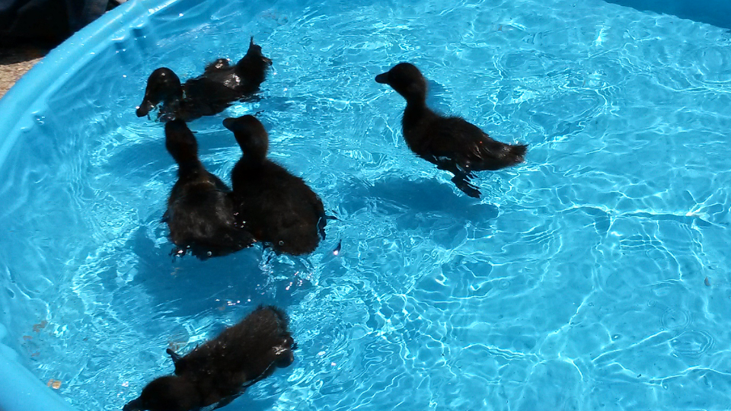

On Monday we had fun watching the ducks swim in a small pool outside!

Track ‘N Field day is Friday, June 3rd. Mr. Clements is still looking for volunteers to run some of the events.

Yearbooks are available for purchase.
Autograph day is scheduled for Wednesday, June 8th.

End-of-the-Year classroom activities are scheduled for Wednesday, June 8th. More information will be coming home

The last day of school for students is Thursday, June 9th. It is a half day. Students are dismissed at 11:15 a.m. No lunches will be served the last day of school.

Message from the school nurse:
Attention parents if your child has medication here at school it needs to be picked up before the end of the school year, otherwise medications will be properly disposed of. Please remember that children cannot transport medications, parents/guardians must come in to the office and sign out their child’s medication. If you have any questions please let us know. I will be sending out another reminder in the near future.

Respectfully,
Elizabeth Rebollar, RN
School Nurse Consultant

Have a wonderful weekend!
**See other side for Calendar of Events**

Sunday | Monday | Tuesday | Wednesday | Thursday | Friday | Saturday
22 | 23 | 24 | 25 | 26 | 27 | 28
 |  |  | Green  Thumb  Club |  | 11:15 Dismissal
29 | 30 | 31 | 1 | 2 | 3 | 4
 | Memorial  Day  No  School |  | Green  Thumb  Club |  | Track &  Field  8:30-10:40 am
5 | 6 | 7 | 8 | 9 | 10
 |  |  | Autograph  Day  End of Year  Celebrations | Last day  for students  11:15  Dismissal

