We have critters of all sorts in the kindergarten rooms! Goldfish and guppies; redworms and night crawlers; chicks and ducklings; and the newly arrived pill bugs and sow bugs.
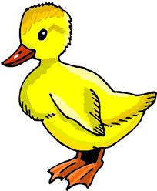
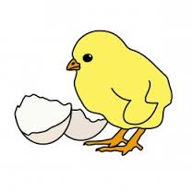

We have been comparing and contrasting the various animals. We made a Venn diagram to record information about chicks and ducklings. We noted similarities, such as,
- they are birds
- they have feathers
- they hatch from an egg
- they have two legs
- they can be different colors

We also recorded their differences…
- ducks can swim, chickens cannot swim
- ducks can fly, chickens cannot fly
- ducks have a rounded bill, chickens have a sharp beak
- ducks have webbed feet, chickens do not have webbed feet

We read books about the farm. Each of us chose an animal to do a report on. After reading a book we took turns sharing what we learned about the animal. We will bring our completed report home soon.

Our new sight words for this week were of and all.

In math we made our own Monster Squeeze game. We had fun playing with our friends. To play the game Player A thinks of a secret number on the number line. Player B takes a turn to guess the number. Player A responds with “my number is larger/greater than __” or
“my number is smaller/less than ___.” Player A moves the monsters along the number line until the monsters ‘squeeze’ the secret number.
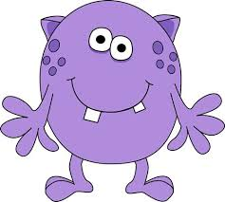

As part of the animal unit we have been recording our observations in a science journal. When the journal is completed it will be graded and sent home.

In social studies we are learning about directions, the compass rose, and how to make a map. Next week we will make a map of our school.

Parents who signed up to chaperone the Betty Brinn museum field trip on Wednesday, May 13th should plan to be at school by 8:00.

If you have not already sent the $10 for the classroom projects and ice cream social raffle basket, please send the money next week. Thank you for supporting these end of the year activities.
Summer Activities
Think Summer, Think Fun!
The Kenosha Unified Recreation Department will again this year offer numerous summer activities for the children in Kenosha. Swim registration begins May 6th. All other class registration begins May 13th. All programs start June 15th. You may go to the Recreation Dept. website for further information www.kusd.edu/departments/recreation-0

June 11th is the last day of school for students. Dismissal is at 11:15.
Have a wonderful weekend!

**See other side for Calendar of Events**
Sunday | Monday | Tuesday | Wednesday | Thursday | Friday | Saturday
10 | 11 | 12 | 13 | 14 | 15 | 16
 |  | Green  Thumb  Club  PTO  meeting  6:00 p.m. |  |  | Leadership Dance  11:30-1:00
17 | 18 | 19 | 20 | 21 | 22 | 23
Betty Brinn
Field Trip

24 | 25 | 26 | 27 | 28 | 29 | 30
 | Memorial Day  (NO school) | Green  Thumb  Club |  |  | Ice Cream Social  5:30-8:00
31 | June 1 | 2 | 3 | 4 | 5 | 6
 |  | Fifth Grade Banquet
7 | 8 | 9 | 10 | 11 | 12 | 13
Student
last day

11:15 dismissal

