This week’s high-frequency word is saw. We listed words with the -ike spelling pattern.
Students will be evaluated on their sight word recognition next week. Please practice reading the words on the attached list with your child.

We read different versions of Goldilocks and the Three Bears. We compared & contrasted the characters and events in the stories. We especially liked Somebody and the Three Blairs.

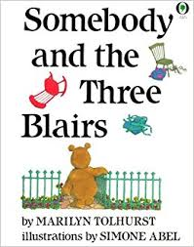

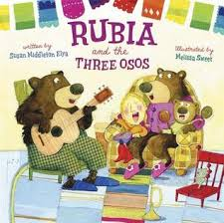

During writer’s workshop we sorted statements by fact vs opinion. We talked about the importance of writing only facts when writing a non-fiction piece. We worked on our farm animal reports and shared them with our classmates.

In math we continued writing on our own number grids. We worked on solving word problems using drawings and number lines.

In science we did another investigation to see the effect that sunlight had on a white rubber surface compared to a black rubber surface. We used a heat lamp as our source of light. We also set them outside on the playground in the sun. We checked the temperature of each after a few minutes. At the beginning of the investigation the surfaces were the same temperature. However, after being placed in the sun for a few minutes the black surface became much hotter! We will use this learning to help answer questions about playground surfaces.

Mark your Calendar:
- Tuesday, May 29th, 6:00 p.m.
Kindergarten Music Program

- Friday, June 1st, 5:30-8:00 p.m.
Ice Cream Social

- Wednesday, June 6th
Green Meadows Petting Farm

- Friday, June 8th
Track & Field Day

- Tuesday, June 12th
End-of-the-Year classroom activities

- Wednesday, June 13th
Dismissal 11:21 – Last day of school

The PTO is still in need of parent volunteers for the Ice Cream Social. You can sign up on the link below.
https://goo.gl/forms/Cx3I6pflLOR0CCHF2

Have a wonderful weekend!

Please see other side for calendar
Sunday | Monday | Tuesday | Wednesday | Thursday | Friday | Saturday
13 | 14 | 15 | 16 | 17 | 18 | 19
20 | 21 | 22 | 23 | 24 | 25 | 26
27 | 28 | 29 | 30 | 31 | June 1 | 2
 |  | Kgn Music  Program  6:00 pm |  |  | Ice Cream  Social  5:30-8:00 pm
3 | 4 | 5 | 6 | 7 | 8 | 9
 |  |  | Green  Meadows  field trip  8:30-2:00 |  | Track &  Field Day
10 | 11 | 12 | 13
Last day of school
11:21 Dismissal

