We had a great time at the Betty Brinn Children’s Museum. We participated in the program Playground Engineers. We learned about simple machines and followed plans to build playground equipment using Tinker Toys.
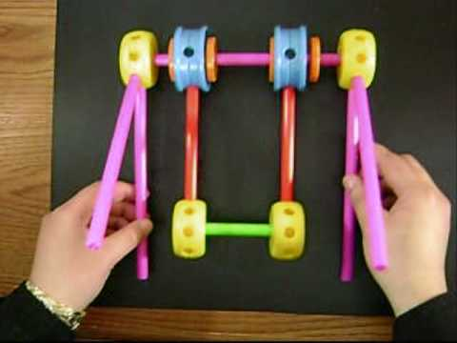

This week we learned the words saw, him, and her. We looked in our library books for these words. Please continue reviewing the kindergarten high-frequency words with your child. The year-end goal is 60 words.

We practiced making words with the
–un spelling pattern.

* * * * * * * * * * * * * *
In math we reviewed 2D and 3D shapes. We described objects by their attributes (length, weight, and number of sides). We continued to work on number combinations to make ten. We practiced telling subtraction number stories and writing the number model/math fact to go with each.

This week the isopods arrived! We looked closely at the pill bugs (Roly Poly) and sow bugs. We prepared a habitat of moist soil and decaying leaves.
Reminders:
Next Friday, May 6th, is the Leadership Sock Hop (11:15-1:00). Permission slips went home on Monday.

The kindergarten music program is Thursday, May 5th, at 6:00 p.m.

Kindergartners should be at school
by 5:45 p.m.

If your child received a speaking part, please practice it with him/her.

The Jeffery Ice Cream Social is Friday, May 20th at 5:30-8:00 p.m. Please watch for notes coming home with additional information regarding classroom raffle basket donations.

Have a wonderful weekend!
**See other side for Calendar of Events**

Sunday | Monday | Tuesday | Wednesday | Thursday | Friday | Saturday
24 | 25 | 26 | 27 | 28 | 29 | 30
 |  | Betty Brinn  Museum  Field Trip |  |  | 11:15 Dismissal  Jeffery  Talent Show
May 1 | 2 | 3 | 4 | 5 | 6 | 7
 |  |  |  | Kindergarten  Music  Program  6:00 pm | 11:15 Dismissal  Sock Hop  11:15-1:00
8 | 9 | 10 | 11 | 12 | 13 | 14
 |  | PTO  Meeting  6:00 pm  library |  |  | Spirit &  Popcorn  Day  11:15 Dismissal
15 | 16 | 17 | 18 | 19 | 20 | 21
11:15 Dismissal

Ice Cream
Social
5:30-8:00

22 | 23 | 24 | 25 | 26 | 27 | 28
 |  |  |  |  | 11:15 Dismissal

PALS Testing
PALS Testing

