This week’s high-frequency words were had and day. We listed words with the -ad and
-ay spelling patterns.

We read different versions of The Three Little Pigs. We made a Venn diagram to compare & contrast the books.
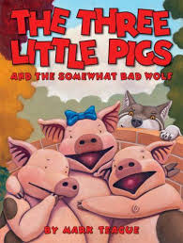
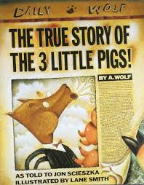

We are practicing retelling stories using
Five Finger Retelling.

Have your child retell a story using this model.
1. Characters
2. Setting
3. Problem
4. Events
5. Solution

In math we are making number books to show what numbers to add together to make that sum. For example,
Make 5

0+5 =5 3+2=5
1+4=5 4+1=5
2+3 =5 5+0=5

In science we read a book and looked at pictures that showed different types of weather. We discussed why people would need to know what the weather will be like today. We described temperature in terms of very cold, cold, cool, warm, hot, and very hot.

Thank you to the parents who chaperoned our trip to the Betty Brinn Children’s museum. The students had fun and represented our school well.
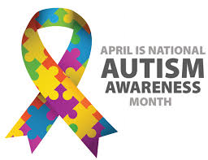

Mark your Calendar:
- Wednesday, April 25 – Earth Day Chat & Chew
5:30 dinner
6:00 program
Please be sure to sign up if you plan to attend so we can get an accurate count before the event.

- Tuesday, May 1 – Safety Center field trip

The kindergarten music program is scheduled for Tuesday, May 29th,
at 6:00 p.m.

Have a wonderful weekend!

Please see other side for calendar
Sunday | Monday | Tuesday | Wednesday | Thursday | Friday | Saturday
15 | 16 | 17 | 18 | 19 | 20 | 21
Bettty Brinn
field trip
22 | 23 | 24 | 25 | 26 | 27 | 28
 |  |  | Earth Day  Chat & Chew |  | PTO  Talent Show
29 | 30 | May 1 | 2 | 3 | 4 | 5
Safety Center
field trip
6 | 7 | 8 | 9 | 10 | 11 | 12
Spirit &
Popcorn
Day
13 | 14 | 15 | 16 | 17 | 18 | 19

