During fourth quarter the kindergarten students will be focusing on reading non-fiction text (informational text). We will research a topic and compare & contrast information from two or more books. Over the next few weeks we will be learning about plants in reading and science.

Our new sight words for this week were look, at, his, and her. We made –ug words.

In our writing this quarter we will learn to write informative pieces, as well as, review opinion and narrative pieces.

* * * * * * * * * * * * * * * * *

In math we are learning about measurement. We used Unifix Cubes to measure the length of objects. We looked at a ruler and practiced measuring objects correctly. We will be comparing attributes of objects, such as, heavier/lighter, longer/shorter, and warmer/cooler.

We practiced telling word problems and writing the equation to go with it.

* * * * * * * * * * * * * * * * *
The fourth quarter science kit is Animals 2 by 2. The kindergarten classes are very excited to be learning about and taking care of goldfish! We observed the fish swim to the surface of the water to eat the food. Next week we will see if the goldfish swim through or around a tunnel placed in the tank.
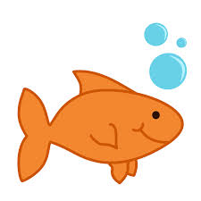

Book fair – Friday, April 17-Wednesday, April 22

You will still be able to sign up for Vigeo at the K & 1 music program. Representatives will be in the cafeteria and computer lab to assist you. Vigeo is a great way to earn money for the school and cash back for you. On your smartphone you scan a QR code at participating businesses. A percentage is given to the school and a percentage is given to you in the form of a check. Please come early or stay after the music program to find out more about Vigeo.

April 22nd at 6:00 p.m. is the kindergarten music program at Jeffery. The lyrics were sent home for the children to practice. You can visit Ms. Roland’s music web page at
http://prairielane.kusd.edu/classrooms/ms-roland The password is PL

April 25th - “Every Kid Needs a Super Hero” 5K walk/run sponsored by Carthage College. You can sign up on the Jeffery web page

http://jeffery.kusd.edu/every-kid-needs-a-superhero/
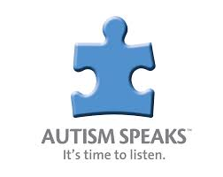
April is Autism
Awareness Month

**See other side for Calendar of Events**
Sunday | Monday | Tuesday | Wednesday | Thursday | Friday | Saturday
12 | 13 | 14 | 15 | 16 | 17 | 18
 | School  resumes | Green Thumb Club Fundraiser  packet due  Green Thumb  Club |  |  | Jeffery  Talent Show  6:00 pm  Popcorn Day  Book Fair  in library
19 | 20 | 21 | 22 | 23 | 24 | 25
 | Book Fair  in library | Book Fair  in library | K & 1  Music  Program  6:00 pm  Book Fair  in library | Mrs. Warren’s class, Safety Center |  | Carthage  5K  Walk/Run
26 | 27 | 28 | 29 | 30 | May 1 | 2
 | Mrs. Duford’s class, Safety Center | Green Thumb  Club
3 | 4 | 5 | 6 | 7 | 8 | 9

