During fourth quarter we will be reading different versions of fairy tales to compare & contrast. We will also read non-fiction books with similar characters.
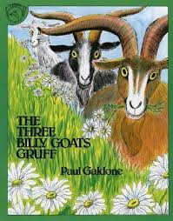
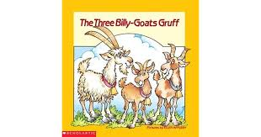

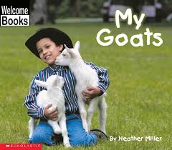

Our writing focus is informational text and how-to books. We enjoyed the book How to Wash a Woolly Mammoth. We shared how we would wash a pet woolly mammoth. We wrote our own step-by-step directions on how to make slime and then watched a video of someone making slime.
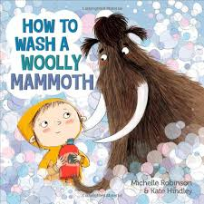

How would you
wash a woolly
mammoth?

This week’s high-frequency words were big, little and put. We listed words with the -ig and -ug spelling patterns.

In math we played a dice addition game. We practiced telling addition and subtraction number stories. We wrote two digit numbers and talked about which is greater and why.
The number with the larger digit in the tens place is greater.
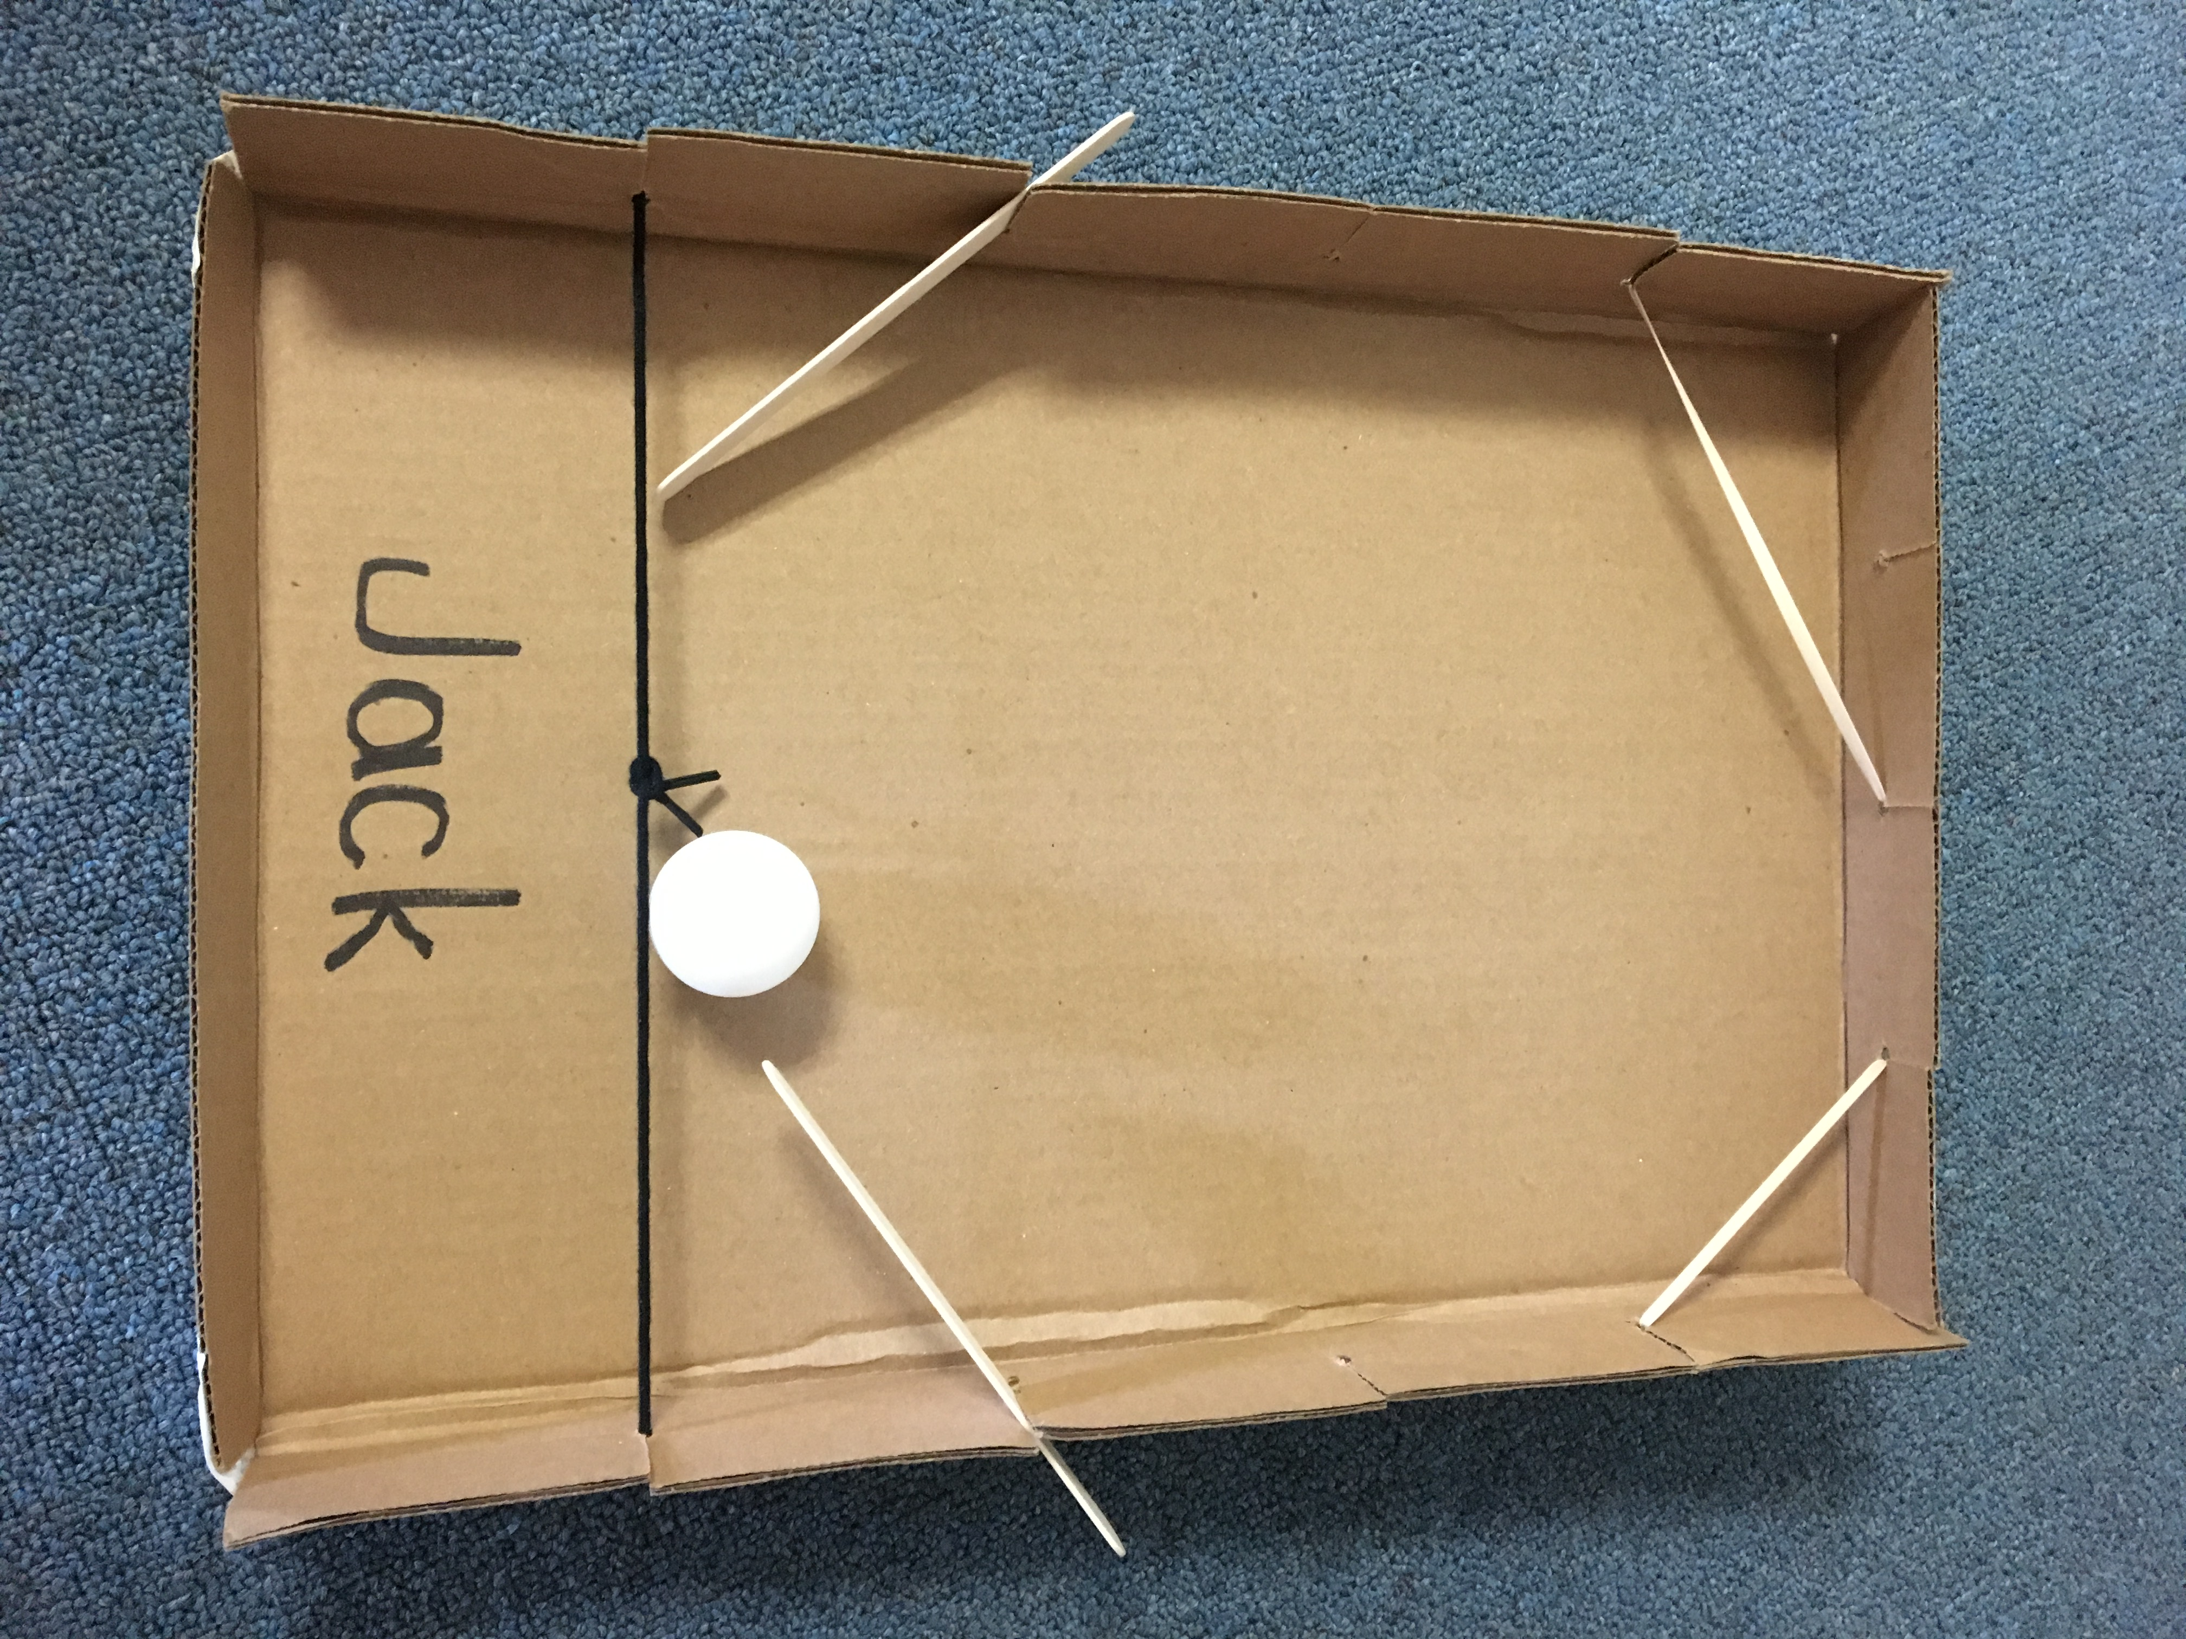
The students were very excited to finish and bring home their pinball machine box model. It was the culminating activity to show interactions and forces that we had been learning about for several weeks.

Reminders:
Tuesday, April 17 – Betty Brinn Children’s museum field trip
- Students and chaperones will need to pack a lunch with a beverage. Chaperones should be at Jeffery by 8:30 a.m. We will return to school by 1:30 p.m.

Wednesday, April 18 – Earth Day Chat & Chew
5:30 dinner
6:00 program
- Please be sure to sign up if you plan to attend so we can get an accurate count before the event.

Mark your Calendar: The kindergarten music program is scheduled for Tuesday, May 29th, at 6:00 p.m.

Have a wonderful weekend!

Please see other side for calendar
Sunday | Monday | Tuesday | Wednesday | Thursday | Friday | Saturday
15 | 16 | 17 | 18 | 19 | 20 | 21
 |  | Bettty Brinn  field trip | Earth Day  Chat & Chew
22 | 23 | 24 | 25 | 26 | 27 | 28
PTO
Talent Show

29 | 30 | May 1 | 2 | 3 | 4 | 5
Safety Center
field trip
6 | 7 | 8 | 9 | 10 | 11 | 12
Spirit &
Popcorn
Day
13 | 14 | 15 | 16 | 17 | 18 | 19

