We graphed jelly beans by color and compared which color had the most and which had the least.

We worked on our paper mache spring baskets and had fun looking around the room for hidden eggs.

We learned the words they and saw.
We listed words with the spelling pattern
–ide.

In math we did an activity using a number cube and counting sticks. After each roll of the die, students pick up that many sticks. When needed they grouped sticks into bundles of ten. Play continued until 100 sticks were bundled into 10 groups of ten.

In social studies we are learning about maps & globes and land & water. Students are expected to be able to identify geographical tools that help them understand their surroundings.
We will learn about the compass rose and map key; and draw a map of the classroom.

As the weather gets
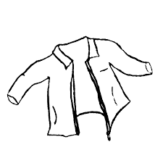
warmer students
will still need to
wear jackets
outside unless
the temperature
reaches 60 degrees.

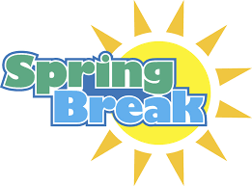
There is no school on Friday. Students return to school on Monday, April 24th.

Notes:
- Jeffery Talent Show
April 28th at 6:00

- Popcorn & Spirit Day
May 9th

- PTO meeting in library
May 9th

- Safety Center field trip
May 15 (Room 119 & 120)
May 25 (Room 118)

- Green Meadows field trip
May 24th
(Permission slips will come home when we return from spring break)

- Memorial Day (No school)
May 29th

Have a wonderful spring break!
**See other side for Calendar of Events**

Sunday | Monday | Tuesday | Wednesday | Thursday | Friday | Saturday
23 | 24 | 25 | 26 | 27 | 28 | 29
 | School  Resumes |  |  |  | Dismissal  11:21  Jeffery  Talent  Show  6:00 pm
30 | May 1 | 2 | 3 | 4 | 5 | 6
Dismissal
11:21

7 | 8 | 9 | 10 | 11 | 12 | 13
Popcorn
& Spirit
Day

Dismissal
11:21

14 | 15 | 16 | 17 | 18 | 19 | 20
 | Safety  Center  (Rooms  119 & 120) |  |  |  | Dismissal  11:21
21 | 22 | 23 | 24 | 25 | 26 | 27
 |  |  | Green Meadows  field trip | Safety  Center  (Room 118) | Dismissal  11:21

PALS Screening

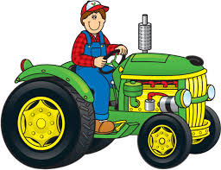
PALS Screening

