The students were very excited when the goldfish arrived this week! We will be learning about the parts of a goldfish and what they need to survive.
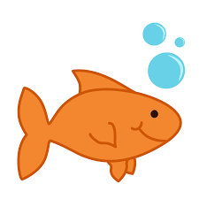

We may compare and contrast goldfish with other fish, like guppies, sharks, etc. In a few weeks we will be getting worms and isopods.

The most recent spelling patterns were –ake and -ike. We did word work activities to build and read new words.

We learned the words do and did.

We will be starting a unit on How-to writing. Students will write step-by-step directions explaining how to make or do something. We practiced this together for “How to build a Snowman”.

In math we rolled number cubes to make a double digit number. Then we discussed how to arrange them to make the larger number.
3
5
5
3

or

We continue to work on addition and subtraction number stories by drawing pictures and writing the number sentence/equation.

We did an activity called “What’s My Rule?” Students are called to stand in the front of the class based on a secret attribute. Students try to guess the “rule”. It might be stripes or short sleeves or shoes with laces. Students had fun making guesses.
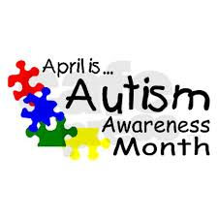

As the weather gets warmer students will still need to wear jackets outside unless the temperature reaches 60 degrees.

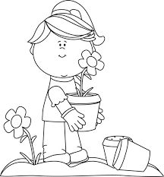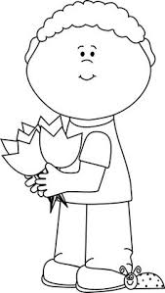

Have a wonderful weekend!
**See other side for Calendar of Events**

Sunday | Monday | Tuesday | Wednesday | Thursday | Friday | Saturday
9 | 10 | 11 | 12 | 13 | 14 | 15
Spring
Break
begins

April 14-23
16 | 17 | 18 | 19 | 20 | 21 | 22
23 | 24 | 25 | 26 | 27 | 28 | 29
 | School  Resumes |  |  |  | Dismissal  11:21  Jeffery  Talent  Show
30 | May 1 | 2 | 3 | 4 | 5 | 6
Dismissal
11:21

7 | 8 | 9 | 10 | 11 | 12 | 13
Dismissal
11:21

PALS Screening
Spring Break

