The kindergarten classes are beginning a unit on ocean animals. We will be reading fiction and non-fiction books on the topic.
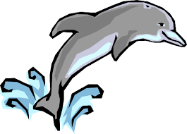

The most recent spelling patterns were –ut and -un. We did word work activities to build and read new words.

We learned the words on, off, up and down.

During writing mini-lessons we discussed word choice. We learned about adjectives and made an anchor chart to help us remember to use describing words in our writing pieces.

During fourth quarter in science we will continue to learn about trees and how they change during each of the seasons. We will compare and contrast what people, plants, and animals need to survive.

In social studies we will be learning about geographic tools (map, globe) and land forms.

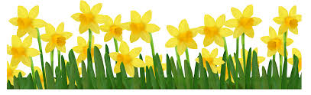

Student quotes about our field trip to the
Betty Brinn Museum

“Betty Brinn was an awesome field trip!”

“I liked building with the Tinker Toys.”

“My favorite part was working on the cars. I liked taking off the wheels and looking under the car.”

“I had so much fun batting the ball in the batting cage.”

Thank you chaperones for helping make the field trip a great learning experience!

Please send a class snack for April.
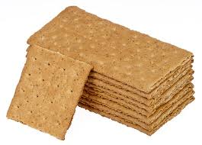
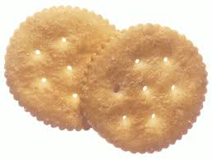

Have a wonderful weekend!
**See other side for Calendar of Events**

Sunday | Monday | Tuesday | Wednesday | Thursday | Friday | Saturday
2 | 3 | 4 | 5 | 6 | 7 | 8
 |  |  |  | Talent Show  Try-outs | 11:15 Dismissal  Talent Show  Try-outs
9 | 10 | 11 | 12 | 13 | 14 | 15
Spring
Break
begins

April 14-23
16 | 17 | 18 | 19 | 20 | 21 | 22
23 | 24 | 25 | 26 | 27 | 28 | 29
 | School  Resumes |  |  |  | Jeffery  Talent  Show
30 | May 1 | 2 | 3 | 4 | 5 | 6

Spring Break

