In March we will be reading books by author and illustrator Theodore
Seuss Geisel (Dr. Seuss).
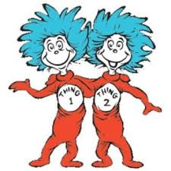

Last week’s high-frequency words were did and find. This week’s words were help and out. We listed words with the -et and -en spelling patterns.

We learned about Five Finger Retelling for fiction stories. This reminds us to include in our retelling of a story:
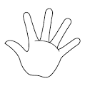
- the characters
- the setting
- the problem
- the events
- the solution

Our focus in Language Arts is opinion and persuasive writing. Each of us shared our opinion about our favorite animal, season, and pet. We made a graph showing our favorite pizza toppings. After reading a book we told about our favorite part of the story and why it was our favorite part.

We read books about dental health and discussed ways to keep our teeth healthy.
- Brush your teeth twice each day.
- Floss your teeth.
- Eat healthy foods.
- Visit the dentist twice a year.

In science we are focusing on force (pushes and pulls). We will do investigations to see what happens when an object exerts force on another object. The learning from the investigations that we do over the next few weeks will culminate in the construction of a class pinball machine.

In math we reviewed addition and subtraction number stories using counters. We used a number line to help us figure out what number comes before or after a given number. We are learning to describe and compare the attributes of shapes (e.g., number of sides, number of corners). Your child should be able to identify the following 2D and 3D shapes:

2D - circle, square, triangle, rectangle, hexagon

3D – sphere, cube, cone, cylinder
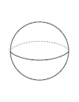
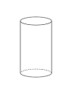
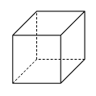

cube cone cylinder sphere

Upcoming Events:
Next week we will be celebrating Read Across America with some fun activities each day.
READ ACROSS AMERICA

Monday – Wear red & white colors (stripes)

Tuesday – Hats off to kindness (wear a hat)

Wednesday – Team up for kindness
(wear baseball apparel)

Thursday – Bring your favorite book

Friday – Crazy for kindness
(wear crazy socks)

Have a wonderful weekend!

Sunday | Monday | Tuesday | Wednesday | Thursday | Friday | Saturday
4 | 5 | 6 | 7 | 8 | 9 | 10
 | Wear red & white colors (stripes) | Hats off to kindness  (wear a hat) | Team up for kindness  (wear baseball apparel)  AUTHOR VISIT | Bring your favorite book | Crazy for kindness  (wear crazy socks)  Popcorn &  Spirit Day  (Popcorn 50¢/bag)  11:21 Dismiss
11 | 12 | 13 | 14 | 15 | 16 | 17
 |  |  |  |  | 11:21 Dismissal
18 | 19 | 20 | 21 | 22 | 23 | 24
 |  |  |  | End of 3rd Quarter | Staff  Work  Day  No School  for Students
25 | 26 | 27 | 28 | 29 | 30 | 31
Spring
Break

March 30-
April 8

April 1 | 2 | 3 | 4 | 5 | 6 | 7

