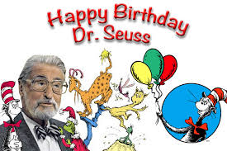

At school we have been reading books by Dr. Seuss and doing some fun school-wide activities. The Cat-in-the-Hat visited us during an assembly. We were so surprised when Thing 1 and Thing 2 showed up, as well!

We will continue to read Dr. Seuss books throughout the month of March.

This week’s spelling pattern was
-et. We learned the words get and did.

We are working on writing sentences with a capital letter, spaces between the words, and punctuation at the end. We noticed quotation marks to show when a character in the story is talking.
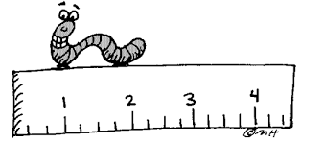

In math we have been learning about measurement. We used our hands and feet to measure things in the room. We discovered the need for a standard unit of measurement if we want the same results every time.

We looked at the hundreds chart and learned how to count by 5s. We made tally marks as we counted to 100 a second time.

We learned to describe 2D shapes as flat and 3D shapes as solid. We learned about the cube, cone, cylinder and sphere.
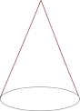
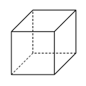

cube cone
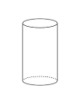
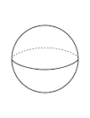

cylinder sphere

A Dr. Seuss March reading challenge went home in your child’s folder. There are many fun ways to read a book. Complete all of them and return it to school to have your picture added to the READ wall of fame!

NOTES:
Friday, March 10
Spirit & Popcorn Day

Thursday, March 23
End of 3rd Quarter

Friday, March 24
Teacher Work Day
No school for students

Have a wonderful weekend!
**See other side for Calendar of Events**

Sunday | Monday | Tuesday | Wednesday | Thursday | Friday | Saturday
5 | 6 | 7 | 8 | 9 | 10 | 11
Popcorn &
Spirit Day

11:15 Dismissal

12 | 13 | 14 | 15 | 16 | 17 | 18
Daylight  Savings |  |  |  |  | 11:15 Dismissal
19 | 20 | 21 | 22 | 23 | 24 | 25
 |  |  |  | End of 3rd Quarter | No School  for Students  Teacher  Work Day
26 | 27 | 28 | 29 | 30 | 31 | Apr 1
 |  |  |  |  | 11:15 Dismissal
2 | 3 | 4 | 5 | 6 | 7 | 8
 |  |  |  | Talent Show  Try-outs | 11:15 Dismissal  Talent Show  Try-outs

