In February we will be reading books by author and illustrator Ezra Jack Keats. We will get to know some of his favorite characters to include in his books (Peter, Archie, Amy).

In class we are reading and discussing both fiction and non-fiction books on the same topic. We discussed features specific to the genre.
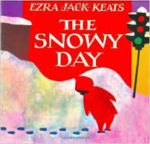
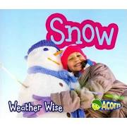

Last week’s high-frequency words were not and got. This week’s words were was, make and take. We learned how the silent ‘e’ changes the vowel sound in words.

can cane
cap cape
kit kite

We listed words with the -ot and -op spelling patterns.

Our focus in writing is now opinion and persuasive writing. When presented with the idea of having pizza for lunch every day, students discussed the pros and cons. Then they shared their opinions and backed them up with supporting details.

In math we learned about tally marks and counting by 5s. We reviewed addition and subtraction number stories using counters. We used a number line to help us figure out what number comes before or after a given number.

In social studies we are learning about maps and globes. We identified land and water on both. We also looked for various landforms on a map.
We had fun during our
Friendship/Valentine Party.
Thank you to the parents
who volunteered to help
with the activities.

* * * * * * * * * * * * * * * * *

Upcoming Events:

Parent-Teacher Conferences
Wednesday, February 21
Student hours 7:25-2:25
Parent-Teacher Conferences
3:10-6:10 p.m.

Thursday, February 22
Student hours 7:25-11:15 a.m.
Parent-Teacher Conferences
12:10-3:10 p.m.
5:00-7:00 p.m.

Friday, February 23
No school for students
Parent-Teacher Conferences
7:10-9:10 a.m.
The book fair will be open
during conferences.

How are you doing on the Six Flags Read to Succeed program? Students who read or are read to for 6 hours and return the reading log will earn a free ticket to Six Flags! Reading logs are due February 22nd.

Have a wonderful weekend!

**See other side for Calendar of Events**

Sunday | Monday | Tuesday | Wednesday | Thursday | Friday | Saturday
18 | 19 | 20 | 21 | 22 | 23 | 24
 |  |  |  | Early Dismissal  11:21 | No School  for Students
25 | 26 | 27 | 28 | Mar 1 | 2 | 3
 |  |  |  |  | 11:21 Dismissal
4 | 5 | 6 | 7 | 8 | 9 | 10
Popcorn &
Spirit Day
(Popcorn 50¢/bag)

11:21 Dismissal
11 | 12 | 13 | 14 | 15 | 16 | 17
 |  |  |  |  | 11:21 Dismissal
18 | 19 | 20 | 21 | 22 | 23 | 24
 |  |  |  |  | 11:21 Dismissal

Parent-Teacher Conferences

