In February we will be reading books by author and illustrator Ezra Jack Keats. We will get to know some of his favorite characters to include in his books (Peter, Archie, Amy).

In class we are reading and discussing both fiction and non-fiction books on the same topic. We discussed features specific to the genre.
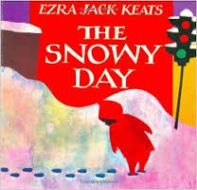
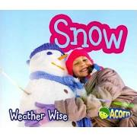

The high-frequency words for this week were was, make and take. We learned how the silent ‘e’ changes the vowel sound in words.

can cane
cap cape
kit kite

Our focus in writing is now opinion and persuasive writing. When presented with the idea of having pizza for lunch every day, students discussed the pros and cons. Then they shared their opinions and backed them up with supporting details.

In math we continue to work on creating and solving addition and subtraction number stories using manipulatives. We are also learning to make larger numbers using tens and ones.
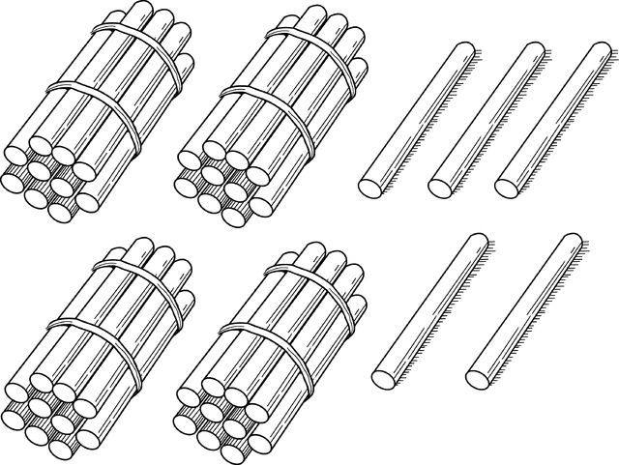
4 tens and 5 ones
45

NOTES:
- The ALiCE presentation at Jeffery is Thursday, February 16th.
5:30 pm – dinner
6:00 pm – program

If you have not signed up but would like to come, you can still sign-up on the link below.
https://docs.google.com/forms/d/e/1FAIpQLSdw0n3Ya7sOJ_FaFR7uAX4oAQKCvs5kqN2kf_wc3pE80USn8A/viewform

- Classroom Friendship/Valentine’s Day activities are on Tuesday, February 14th. Students can bring valentines to pass out to their classmates.

- How are you doing on the Six Flags Read to Succeed program? Students who read or are read to for 6 hours and return the reading log will earn a free ticket to Six Flags! Reading logs are due February 20th.

Parent-Teacher Conferences
Wednesday, February 22
Student hours 7:25-2:25
Parent-Teacher Conferences
3:10-6:10 p.m.

Thursday, February 23
Student hours 7:25-11:15 a.m.
Parent-Teacher Conferences
12:10-3:10 p.m.
5:00-7:00 p.m.

Friday, February 24
No school for students
Parent-Teacher Conferences
7:10-9:10 a.m.

Have a wonderful weekend!
**See other side for Calendar of Events**

Sunday | Monday | Tuesday | Wednesday | Thursday | Friday | Saturday
12 | 13 | 14 | 15 | 16 | 17 | 18
 |  | Dental  Presentation  Classroom Friendship  Parties |  | ALiCE  Presentation  5:30 dinner  6:00 program | 11:15 Dismissal
19 | 20 | 21 | 22 | 23 | 24 | 25
 | Six Flags  Read to  Succeed  Record Sheet  due |  | Student hours  7:25-2:25  Parent-Teacher  Conferences  3:10-6:10 pm | Student hours  7:25-11:15 am  Parent-Teacher  Conferences  12:10-3:10 pm  5:00-7:00 pm | (NO school  for students)  Parent-Teacher  Conferences  7:10-9:10 am
26 | 27 | 28 | Mar 1 | 2 | 3 | 4
 |  |  |  |  | 11:15 Dismissal
5 | 6 | 7 | 8 | 9 | 10 | 11
Popcorn &
Spirit Day

11:15 Dismissal

12 | 13 | 14 | 15 | 16 | 17 | 18
 |  |  |  |  | 11:15 Dismissal

