This week we learned the letters Q,q and Y,y.
We have now finished learning the entire alphabet, but will continue reviewing the letters and sounds in isolation and within words.

Our high-frequency words were are and what.

During the month of December the kindergarten classes have been learning about author Laura Numeroff and illustrator Felicia Bond. We especially enjoyed reading the book If You Give a Mouse a Cookie.
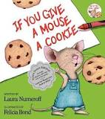

Other titles include:
If You Give a Moose a Muffin,
If You Give a Pig a Pancake,
If You Give a Pig a Party,
If You Give a Cat a Cupcake and
If You Take a Mouse to the Movies.

You can try writing a story of your own following the same style!

* * * * * * * * * * * * * * * * *
In math we discussed the terms more/greater than and less/less than. We played the card game Top-It; otherwise known as War. We learned to describe teen numbers as

“a ten and some ones”
Fourteen is a ten and four ones.

* * * * * * * * * * * * * * * * *
In Social Studies we are learning about family traditions and celebrations. We will also research winter traditions from around the world to discover their cultural significance.

Raffle tickets for the Great Jeffery Raffle fundraiser are still being sold. Check out all the great raffle items or print more raffle tickets on the Jeffery webpage.

Please help your child dress for the cold weather. Students go outside for recess every day unless it is raining or the temperature drops below 10 degrees.
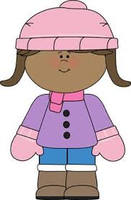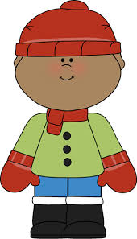

Upcoming Events:

December 15th
Snowflake Dance 11:30-1:00

December 18th
The Great Jeffery Raffle Drawing

December 19th
Classroom Winter Activity
(12:40-2:00)

December 20- January 2
Winter Break

January 3
School Resumes

Have a wonderful weekend!

**See other side for Calendar of Events**

Sunday | Monday | Tuesday | Wednesday | Thursday | Friday | Saturday
10 | 11 | 12 | 13 | 14 | 15 | 16
11:21
Dismissal

Snowflake
Dance
11:30-1:00
17 | 18 | 19 | 20 | 21 | 22 | 23
 | The  Great Jeffery Raffle  Drawing | Winter  Classroom  Activity  12:40-2:00 | Winter  Break  Begins
24 | 25 | 26 | 27 | 28 | 29 | 30
31 | Jan 1 | 2 | 3 | 4 | 5 | 6
 |  |  | School Resumes |  | 11:21 Dismissal
7 | 8 | 9 | 10 | 11 | 12 | 13
Popcorn &
Spirit Day
(Popcorn 50¢/bag)

11:21 Dismissal

The Great Jeffery Raffle ticket sales

Winter Break

