Last week and this week we learned the high-frequency words for, want and do.
We read the books Do You See Santa? and
What Does Santa Need for His Trip?

* * * * * * * * * * * * * * * * *

In social studies we have been learning about December celebrations around the world. We read books about Hanukkah and made potato latkes. We enjoyed the latkes with applesauce.
We, also, read books about Christmas, Las Posadas, and Kwanzaa. When talking about the celebrations we learned that most celebrations have family and friends together with special lights, special music, special food, special clothes, special decorations, and the giving of gifts.

* * * * * * * * * * * * * * * * *

In math we used two Ten-Frames to make the teen numbers. We learned the teen numbers are a group of ten and some more ones.

10 + 7 = 17

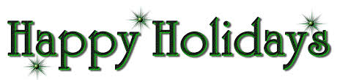

**See other side for Calendar of Events**

Sunday | Monday | Tuesday | Wednesday | Thursday | Friday | Saturday
6 | 7 | 8 | 9 | 10 | 11 | 12
Popcorn &
Spirit Day
(Popcorn 50¢/bag)

11:15 Dismissal
13 | 14 | 15 | 16 | 17 | 18 | 19
11:15 Dismissal

Snowflake
Ball
11:15-1:00

20 | 21 | 22 | 23 | 24 | 25 | 26
 | Great Jeffery  Raffle  Assembly | Classroom Winter  Activities |  |  | 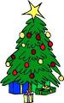
27 | 28 | 29 | 30 | 31 | 1 | 2
New Year’s
Day
3 | 4 | 5 | 6 | 7 | 8 | 9
 | School  Resumes |  |  |  | 11:15 Dismissal

Winter Break

