This week we reviewed the letters, sounds, and sight words. We focused on listening for ending sounds in words.

Our high-frequency words were **will, be** and **for**.

Our writing focus has been *personal narrative*.

Students should be able to tell, with some detail, the beginning, middle, and end of their story. When reading a book with your child, ask them about the characters and the setting. Help them identify the main idea.

We wrote letters to Santa with the help of our upper grade reading buddies.

* * * * * * * * * * * * * * * * *

In math we learned how to use a number line to add. For example, start on 0, take 3 steps forward, then take 2 more steps. What number will you land on? 3 + 2 = 5

We learned how to play the card game Top It. It is like the game War. When playing the game we use the math terms ‘more’ and ‘less’.

* * * * * * * * * * * * * * * * *

This week and next week we will continue to learn about December celebrations around the world. We read books about Hanukkah and made potato latkes. We enjoyed the latkes with applesauce. Yum! We, also, read books about Christmas, Las Posadas, and Kwanzaa. When talking about the celebrations we learned that most celebrations have family and friends together with special lights, special music, special food, special clothes, special decorations, and the giving of gifts.

**The Great Jeffery Raffle drawing is Monday.**

**The Kindergarten music program is Tuesday, December 20th, at 6:00 p.m.**

**Students should be at school by 5:45 p.m.**

**We will be collecting hats, mittens, and gloves to be donated to the Shalom Center.**



**Please help your child dress for the cold weather. Students go outside for recess every day unless it is raining or the temperature drops below 10 degrees.**

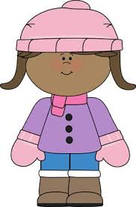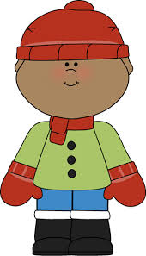



School resumes on Tuesday, January 3rd.

Have a wonderful weekend!



*\*\*See other side for Calendar of Events\*\**

|  |  |  |  |  |  |  |
| --- | --- | --- | --- | --- | --- | --- |
| **Sunday** | **Monday** | **Tuesday** | **Wednesday** | **Thursday** | **Friday** | **Saturday** |
| **18** | **19** | **20** | **21** | **22** | **23** | **24** |
|  | **Great Jeffery**  **Raffle**  **Assembly** | **Kindergarten**  **Music**  **Program**  **6:00 pm** | **Classroom Winter**  **Activities** |  |  |  |
| **25** | **26** | **27** | **28** | **29** | **30** | **31** |
| C:\Users\rewarren\Desktop\Christmas tree.jpg |  |  |  |  |  |  |
| **1** | **2** | **3** | **4** | **5** | **6** | **7** |
| **New Year’s**  **Day** |  | **School**  **Resumes** |  |  |  |  |
| **8** | **9** | **10** | **11** | **12** | **13** | **14** |
|  |  | **PTO meeting**  **in library**  **6:00 pm** |  |  | **Popcorn &**  **Spirit Day**  (Popcorn 50¢/bag)  **11:15 Dismissal** |  |
| **15** | **16** | **17** | **18** | **19** | **20** | **21** |
|  | **MLK Day**  **NO School** |  |  |  | **End of 2nd**  **Quarter**  **Staff Work Day** |  |

**Winter Break**

**Winter Break**