This week we learned the letters L,l and W,w. Our high-frequency words were here, is and this. Next week will be a review week for the letters, sounds, and words learned so far.

We worked on the book This is the Feast. We rearranged the letters to spell the word Here in each sentence.

Next week we will review the word this with the book This is Thanksgiving.

In our journals we are working on writing longer sentences by stretching/sounding out words. We use the word wall as a resource to correctly spell the high- frequency words learned so far. This week we wrote…

Here is my friend. We like to ____________.

* * * * * * * * * * * * * * * * *
In math we talked about measurement. We discussed situations when measuring the length of something would be important (i.e., building things, sewing, etc.) We made a stack of 10 Unifix cubes and measured objects around the room to see if they would fit inside a school supply box. We practiced measuring the length of objects accurately.

In math we each made our own Monster Squeeze game. To play a friend thinks of a mystery number between one and twenty. Then we get turns to guess the number. After each guess the friend moves one monster along the number line saying whether the mystery number is bigger/more than or smaller/less than the number given. The game ends when the monsters squeeze the mystery number. We had fun playing this game with partners.

We talked about birth order and made a graph showing this.

In science we continued learning about balance and counterweights. We checked to see if it was easier to balance on one foot with our arms at our sides or with our arms out as counterweights.

We did an experiment to see if we could balance a cardboard ‘crayfish’ on one finger. We tried many ways to try to get the crayfish to balance. Then we used clothespins as counterweights and discussed where the clothespins were in relation to our finger when the crayfish balanced. We discovered there was more than one way to do this.

We made observations and discussed how the weather changes during the seasons.

In Social Studies we read books about Thanksgiving and family. Students made a turkey to tell what they are thankful for.

On Wednesday, next week, the kindergarten classes will be getting together to celebrate Thanksgiving with a small treat.

- Students are dismissed at 11:15 on Wednesday.

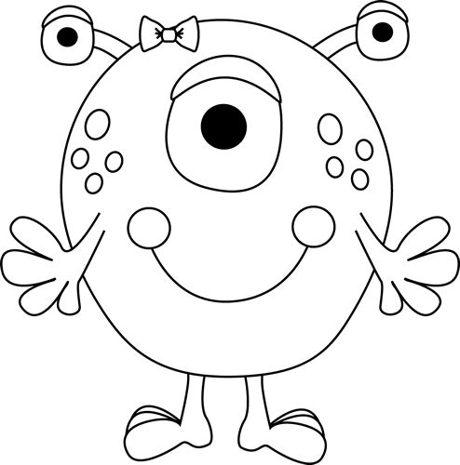
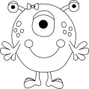1 2 3 4 5 6 7 8 9 10

Have a wonderful weekend!

**See other side for Calendar of Events**

Sunday | Monday | Tuesday | Wednesday | Thursday | Friday | Saturday
15 | 16 | 17 | 18 | 19 | 20 | 21
 |  | VIP  Lunch | VIP  Lunch | VIP  Lunch
22 | 23 | 24 | 25 | 26 | 27 | 28
 |  |  | 11:15 Dismissal  ½ day for students  & staff | Thanksgiving  Day | No School | No School
29 | 30 | Dec 1 | 2 | 3 | 4 | 5
 | Family Tree  Project due  Book-It  sheet due |  | Book  Order due |  | The Great  Jeffery Raffle  (5th grade  fundraiser)
6 | 7 | 8 | 9 | 10 | 11 | 12
13 | 14 | 15 | 16 | 17 | 18 | 19

