This week we learned the letters U,u and K,k. Our high-frequency words were here and is. Next week’s word is this. We worked on the book Here is the Feast.

In our journals we are working on writing longer sentences by stretching/sounding out words. We use the word wall as a resource to correctly spell the high- frequency words. This week we wrote…

Here is my family.
Then we wrote two more sentences to tell something our family likes to do together.

* * * * * * * * * * * * * * * * *
In math we talked about measurement. We discussed situations when measuring the length of something would be important (i.e., building things, sewing, etc.) We made a stack of 10 Unifix cubes and looked for objects in the room longer and shorter than the 10 cubes.
We practiced measuring the length of objects accurately.

We had fun learning a new math game. Then we each made our own Monster Squeeze game. To play, a friend thinks of a mystery number between one and twenty. Then we get turns to guess the number. After each guess the friend moves one monster along the number line saying whether the mystery number is bigger/more than or smaller/less than the number given. The game ends when the monsters squeeze the mystery number. We had fun playing this game with partners.
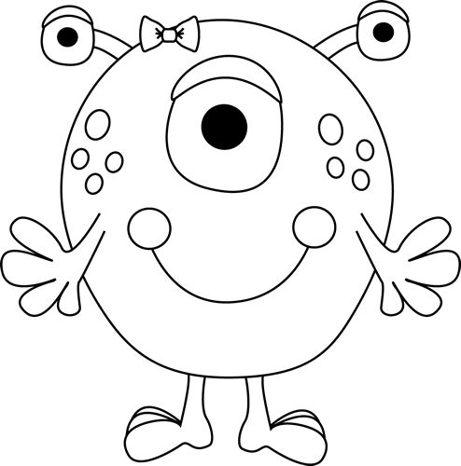
1 2 3 4 5 6 7 8 9 10

Next week we will be talking about where each of us fits in our family (youngest, middle, oldest, or only child). Then we will make a graph to show our birth order.

In Social Studies we learned about Thanksgiving then and now. Students made a turkey to tell what they are thankful for. We read non-fiction/informational text books about turkeys and wrote sentences to tell what we learned.

On Wednesday, next week, the kindergarten classes will be getting together to celebrate Thanksgiving with a small treat.
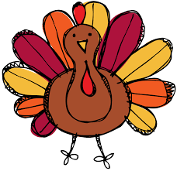

- Students are dismissed at 11:21 on Wednesday.

Have a wonderful weekend!

**See other side for Calendar of Events**

Sunday | Monday | Tuesday | Wednesday | Thursday | Friday | Saturday
19 | 20 | 21 | 22 | 23 | 24 | 25
 |  |  | 11:21 Dismissal  ½ day for students  & staff | Thanksgiving  Day  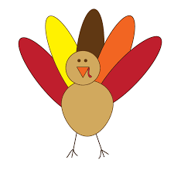 | No School
26 | 27 | 28 | 29 | 30 | Dec 1 | 2
11:21
Dismissal
3 | 4 | 5 | 6 | 7 | 8 | 9
Spirit &
Popcorn
Day

11:21
Dismissal
10 | 11 | 12 | 13 | 14 | 15 | 16
11:21
Dismissal
17 | 18 | 19 | 20 | 21 | 22 | 23
 |  | Winter  Classroom  Activity | Winter  Break  Begins

