This week we learned the letters K,k and U,u. Our high-frequency words were what and you.

We read books about families and made a list of family words. This list will be displayed so it can be used as a reference for reading and writing.

Each of us drew a picture and wrote a sentence about what we like to do with our family. This will be made into a class book.
We talked about birth order and where each of us fit in the family. We made a graph

In November we have been reading books by author & illustrator Tomie dePaola. Each month we will introduce a new author & illustrator for our author/illustrator study.

At Jeffery School we are doing Close Reading. During a close read students are given short complex passages that require rereading and digging deeper to analyze what the text says and what was the author’s point.
Readers interact with the text by marking words and phrases, looking up definitions, and thinking about the structure of the text. Close reading requires students to actually think and understand what they are reading. In kindergarten we are beginning this process slowly by reading one or two paragraphs about a topic and underlining unfamiliar words. We do a vocabulary lesson and reread the text for deeper understanding.

* * * * * * * * * * * * * * * * *
In math we have been using the terms ‘more/greater than’ and ‘less/less than’. We learned how to play the Monster Squeeze game on the ipad. Students will be receiving an Everyday Math online username and password in order to have access to grade level games and activities.
During small group time we matched dominoes to number cards. We practiced counting carefully and accurately.

In science we are learning about forces & interactions, balance & motion, and push & pull. We will continue to talk about weather and climate that was introduced during first quarter. We record the weather during calendar.

The Puffin fundraiser is due Tuesday. Please enclose the money with the order forms. The delivery date is Wednesday, December 17th at 2:00.

The Jeffery Leadership Council is collecting boxes of cereal until Friday, November 21.

How are you doing on the Family Tree project? The children will share about their project before being displayed in the hall.
Please help your child dress for the cold weather. Students go outside for recess every day unless it is raining or the temperature drops below 10 degrees.

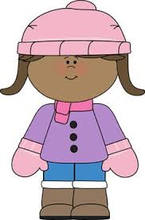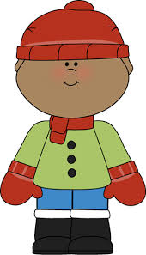

If your child does not have a change of clothes at school, please send an extra set of pants, shirt, socks & underwear. Sometimes socks get wet during recess or milk might spill during lunch.

Have a wonderful weekend!

**See other side for Calendar of Events**

Sunday | Monday | Tuesday | Wednesday | Thursday | Friday | Saturday
 |  |  |  |  |  | 1
2 | 3 | 4 | 5 | 6 | 7 | 8
9 | 10 | 11 | 12 | 13 | 14 | 15
 | Original  Works  orders due | Green  Thumb  Club |  |  | Popcorn &  Spirit Day  (Popcorn 50¢/bag)  Box tops due  Scholastic  Book order  due
16 | 17 | 18 | 19 | 20 | 21 | 22
 |  | Puffin  Fundraiser  Orders &  Money due |  |  | Family Tree  Project due  Last day to donate boxes of cereal
23 | 24 | 25 | 26 | 27 | 28 | 29
 |  | Green  Thumb  Club | Book-It  sheet due  ½ day for students  & staff  11:15 Dismissal | Thanksgiving  Day | No School | No School
30

