This week we learned the letters K,k and U,u. Our high-frequency words were what and you.

We read books about families and made a list of family words. This list will be displayed so it can be used as a reference for reading and writing. Each of us drew a picture and wrote a sentence about what we like to do with our family. This will be made into a class book.

In November we have been reading books by author & illustrator Irene Smalls. Each month we will introduce a new author & illustrator for our author/illustrator study.

At Jeffery School we are doing Close Reading. During a close read students are given short complex passages that require rereading and digging deeper to analyze what the text says and what was the author’s point.
Readers interact with the text by marking words and phrases, looking up definitions, and thinking about the structure of the text. Close reading requires students to actually think and understand what they are reading. In kindergarten we are beginning this process slowly by reading one or two paragraphs about a topic and underlining unfamiliar words. We do a vocabulary lesson and reread the text for deeper understanding.

* * * * * * * * * * * * * * * * *
On Monday, Jeffery School had a very special Veteran’s Day assembly. There were close to twenty veterans that came and spoke to the students.

Your child is bringing home directions for the Family Tree project? The projects will be displayed in the hall near the kindergarten classrooms.

In math we have been using the terms ‘more & less and greater than & less than. We learned how to play the Monster Squeeze game on the ipad. We talked about the Tricky Teens. Teen numbers are often a challenge for young children. We learned that teen numbers are a group of ten and some more ones. We practiced making teen numbers with Unifix cubes.

A group of 10 cubes and 3 more cubes makes 13 cubes.

In science we are learning about forces & interactions, balance & motion, and push & pull. We tried balancing on one foot and discovered that using our arms as a counterbalance helped us to balance better. We will continue to talk about the weather and climate unit that was introduced during first quarter. We record the weather each morning during calendar.
Please help your child dress for the cold weather. Students go outside for recess every day unless it is raining or the temperature drops below 10 degrees.

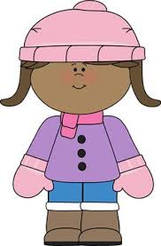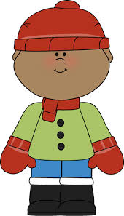

If your child does not have a change of clothes at school, please send an extra set of pants, shirt, socks & underwear. Sometimes socks get wet during recess or milk might spill during lunch.

Have a wonderful weekend!

**See other side for Calendar of Events**

Sunday | Monday | Tuesday | Wednesday | Thursday | Friday | Saturday
8 | 9 | 10 | 11 | 12 | 13 | 14
Popcorn &
Spirit Day
(Popcorn 50¢/bag)

15 | 16 | 17 | 18 | 19 | 20 | 21
American  Education  Week |  | VIP  Lunch | VIP  Lunch | VIP  Lunch
22 | 23 | 24 | 25 | 26 | 27 | 28
 |  |  | ½ day for students  & staff  11:15 Dismissal | Thanksgiving  Day  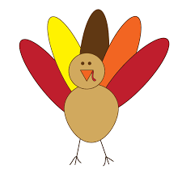 | No School
29 | 30 | Dec 1 | 2 | 3 | 4 | 5
Book-It
sheet due

Family Tree
Projects due
6 | 7 | 8 | 9 | 10 | 11 | 12

