This week we learned the letters K,k and U,u. Our high-frequency words were what and you.

We read books about families and made a list of family words. This list will be displayed so it can be used as a reference for reading and writing. Each of us drew a picture and wrote a sentence about what we like to do with our family. This will be made into a class book.

In November we have been reading books by author & illustrator Irene Smalls. Each month we will introduce a new author & illustrator for our author/illustrator study.

* * * * * * * * * * * * * * * * *
In math we have been using the terms ‘more & less and greater than & less than. We learned how to play the Monster Squeeze game on the ipad. We talked about the Tricky Teens. Teen numbers are often a challenge for young children. We learned that teen numbers are a group of ten and some more ones. We practiced making teen numbers with Unifix cubes.

A group of 10 cubes and 3 more cubes makes 13 cubes.

The second quarter science kit is Forces & Interactions. Students will learn about
balance & motion and push & pull.

In social studies students will identify how their past and culture influence them. They will learn that history relates to events, people, and places of other times.

On Thursday, Jeffery School had a very special Veteran’s Day assembly. There were close to twenty veterans that came and spoke to the students.

* * * * * * * * * * * * * * * * *
A monthly behavior chart is stapled in all the students’ folders. This is meant to be a form of communication for parents to know how well their child behaved at school each day. Students have been told that “Every day is a fresh start.” Students begin each day on a green light. If a student is not making a good choice, he/she receives a warning. If the behavior occurs again, the child will have a yellow dot on the behavior chart. A red light is reserved for incidents that involve aggressive behaviors. At that point, the parent will be contacted via a note, email, or phone call.

* * * * * * * * * * * * * * * * *
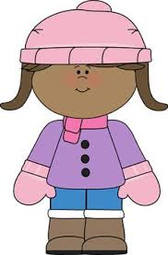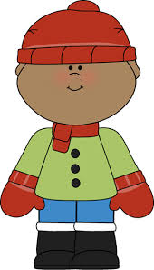
Please help your child dress for the cooler weather. Students go outside for recess every day unless it is raining.

If your child does not have a change of clothes at school, please send an extra set of pants, shirt, socks & underwear. Sometimes socks get wet during recess or milk might spill during lunch.

Mark Your Calendar! The kindergarten and first grade music program is scheduled for Tuesday, December 20th.

Have a wonderful weekend!

**See other side for Calendar of Events**

Sunday | Monday | Tuesday | Wednesday | Thursday | Friday | Saturday
6 | 7 | 8 | 9 | 10 | 11 | 12
 |  |  | Family  Art Night | Veteran’s Program | Popcorn &  Spirit Day  (Popcorn 50¢/bag)
13 | 14 | 15 | 16 | 17 | 18 | 19
American  Education  Week | Dress as your favorite book character | Dress as your favorite super hero  VIP  Lunch  PTO meeting  6:00 pm | Dress as  your favorite teacher  VIP  Lunch  OrigianlWorks  order forms due | Dress for your future career  or college  VIP  Lunch | Wear your Jeffery colors
20 | 21 | 22 | 23 | 24 | 25 | 26
 |  |  | ½ day for students  & staff  11:15 Dismissal | Thanksgiving  Day  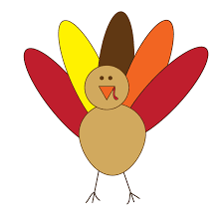 | No School
27 | 28 | 29 | 30 | Dec 1 | 2 | 3
Book-It
sheet due

4 | 5 | 6 | 7 | 8 | 9 | 10

