After tasting red, yellow, and green apples, we created a graph to record which kind of apple people liked most.
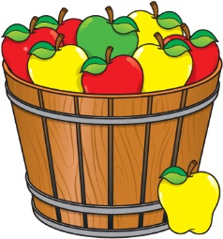
On Wednesday we
made applesauce.
Everyone had a turn
to help cut the apple
slices and turn the
handle on the food mill
after the apples were cooked. Many of us liked the applesauce with cinnamon. Yum!

This week we learned the letters F,f and N,n. Our high-frequency words were see and a. We read a book with these words and wrote sentences in our journals.

We talked about the importance of spaces between words when we read and write.

* * * * * * * * * * * * * * * * *
During Language Arts we practice Three Ways to Read a Book:

- Read the pictures.
- Read the words.
- Retell the story.

Our goal is to build stamina to be able to Read to Self for a few minutes uninterrupted. This will be a year-long goal.

* * * * * * * * * * * * * * * * *
In Math we practiced writing numbers correctly.
We also worked on putting the numbers 1-9 in order. We learned about sorting objects by their attributes. Some of us sorted the objects by color and others sorted by shape.

Please help your child learn his/her eight digit student ID number. This is their username and password to login on the computers in the lab.
Knowing this number will help your child get on the computer faster and ultimately spend more time on the lesson.

Your child brought home a Pizza Hut Book-It sheet to keep track of 12 books read during the month. When the sheet is returned your child will receive a coupon for a free personal pan pizza. The Book-It program runs October through March.

* * * * * * * * * * * * * * * * *
October is National Bullying Prevention month. Students will be allowed to sign the pledge this week in the computer lab.

Pledge to stand up to Bullying:
http://www.kusd.edu/stand-kenosha
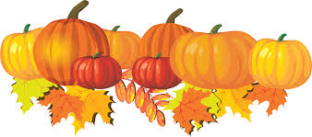

Have a wonderful week!

Mrs. Duford
mduford@kusd.edu

Mrs. Warren
rewarren@kusd.edu

Please see Calendar of Events
on other side.

Sunday | Monday | Tuesday | Wednesday | Thursday | Friday | Saturday
 |  |  | 1 | 2 | 3 | 4
5 | 6 | 7 | 8 | 9 | 10 | 11
 | Wear BLUE  for  STAND UP KENOSHA |  |  | Wear RED  for all school picture | Popcorn &  Spirit Day  (Popcorn 50¢/bag)  Scholastic  Book order  due
12 | 13 | 14 | 15 | 16 | 17 | 18
 | Columbus Day  Kindergarten  Screening |  |  | Kindergarten  Field trip to  Apple Holler | Jeffery PTO  Fall Fest  5:30-8:00 pm
19 | 20 | 21 | 22 | 23 | 24 | 25
 |  |  | Student hours  7:25-2:25  Parent-Teacher  Conferences  3:10-6:10 pm | Student hours  7:25-11:15 am  Parent-Teacher  Conferences  12:10-3:10 pm  5:00-7:00 pm | (NO school  for students)  Parent-Teacher  Conferences  7:10-9:10 am
26 | 27 | 28 | 29 | 30 | 31
 |  |  |  | End of  1st Quarter | (NO school  for students)  Teacher  Work Day

