This week we learned the letters G,g and R,r. Our high-frequency words were go and to. We read books with these words and wrote sentences in our journals. Your child should be able to read the following words in isolation and in a sentence.

I like the and see a
we can go to

The kindergarten classes will finish the PALS assessment next week.

We are getting better at identifying the characters and setting in the books we read. We are also focusing on being able to retell the beginning, middle, and end of stories. Students will be expected to draw pictures for each part of a story.

In class and in the library we discussed what makes a book either fiction or non-fiction. We made an anchor chart to help us remember this.

Fiction is make-believe.
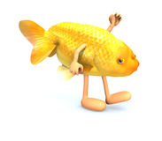
Non-fiction is real-life.
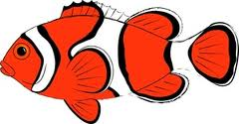

We are working on spelling and writing our first and last names. When reading and writing, we listen for the sounds in words by sounding them out (saying them slowly).

* * * * * * * * * * * * * * * * *
In Math we are practicing writing numbers to 10, counting to 100 by 1s and 10s, and identifying shapes. By counting the days of school, we learned to group straws into bundles of ten. We learned the teen numbers are a bundle of ten straws and some more.
The kindergarten students are practicing their reading and math skills on the following websites and others that can be accessed from the Jeffery home page.

www.abcya.com
www.starfall.com
www.ixl.com

The students are still learning their ixl username and password. A letter with this information was sent home and a label is on their school folder, as well.

We are still collecting new children’s socks during the month of October.

Next week is Red Ribbon Week. Students and staff will be participating in the following activities:

Monday: Packer Day
Tuesday: Crazy Hair & Socks Day
Wednesday: Wear Red
Thursday: Wear your shirt backwards

We look forward to meeting with you to discuss your child’s progress at Parent-Teacher conferences next week.

Have a wonderful weekend!
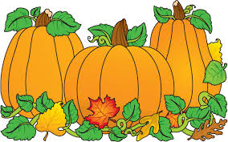

Picture retake day is
Tuesday, October 27

**See other side for Calendar of Events**

Sunday | Monday | Tuesday | Wednesday | Thursday | Friday | Saturday
11 | 12 | 13 | 14 | 15 | 16 | 17
Jeffery PTO
Fall Fest
5:30-8:00 pm
18 | 19 | 20 | 21 | 22 | 23 | 24
Red  Ribbon  Week | Wear  Packer  Colors  Book Fair | Crazy Hair  and Socks  Book Fair | Wear Red  Student hours  7:25-2:25  Parent-Teacher  Conferences  3:10-6:10 pm  Book Fair | Inside Out Day  Student hours  7:25-11:15 am  Parent-Teacher  Conferences  12:10-3:10 pm  5:00-7:00 pm  Book Fair | (NO school  for students)  Parent-Teacher  Conferences  7:10-9:10 am  Book Fair
25 | 26 | 27 | 28 | 29 | 30 | 31
 |  | Picture  Retakes |  | End of  1st Quarter  Book-It  sheet due | (NO school  for students)  Teacher  Work Day
Nov 1 | 2 | 3 | 4 | 5 | 6 | 7
8 | 9 | 10 | 11 | 12 | 13 | 14
PTO meeting
6:00 pm
in the
library

