This week we learned the letters G,g and R,r. Our high-frequency words were go and to. We read books with these words and wrote sentences in our journals. Your child should be able to read the following words in isolation and in a sentence. We will be assessing the students over the next two weeks on reading and writing these words.

I like the and see a
we can go to

We are getting better at identifying the characters and setting in the books we read. We used a graphic organizer to show the story elements.

Who? Did what? Where?
(character) (events) (setting)
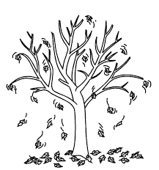

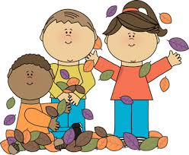
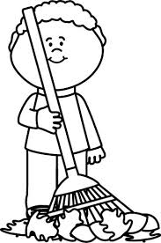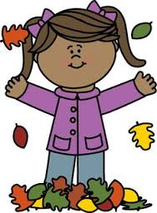

The children are playing with leaves outside in fall.

After drawing the corresponding parts of the story we put them together to write a one sentence summary.

We used the same idea to create a story of our own. Then we shared our stories with the class. Here is one example:

Who? Did what? Where?
(character) (events) (setting)
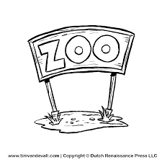
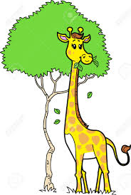
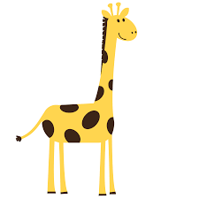

A giraffe is eating leaves at the zoo.

We are also focusing on being able to retell the beginning, middle, and end of stories. Students will be expected to draw pictures for each part of a story. These pictures can be stapled together to make a book.

We are working on spelling and writing our first and last names accurately.

When reading and writing, we listen for the sounds in words by “stretching” the word slowly/”sounding it out.” It is very important for children to be able to separate a word into its individual sounds.
* * * * * * * * * * * * * * * * *
In Math we are practicing writing numbers to 10, counting to 100 by 1s and 10s, and identifying shapes. By counting the days of school, we learned to group straws into bundles of ten. We learned the teen numbers are a bundle of ten straws and some more.

The kindergarten students are practicing their reading and math skills on the following websites that can be accessed from the Jeffery home page.
www.abcya.com
www.starfall.com
www.ixl.com

Next week is Red Ribbon Week. Students and staff will be participating in the daily activities posted on the calendar on the back.

Sunday, October 16th Jeffery Color Run

Thursday, October 20th Kgn Field Trip

Friday, October 21st Fall Fest 5:30-8:00 pm

Wed-Fri, October 26th-28th
Parent-Teacher Conferences

**See other side for Calendar of Events**

Sunday | Monday | Tuesday | Wednesday | Thursday | Friday | Saturday
16 | 17 | 18 | 19 | 20 | 21 | 22
PTO Color Run  1:00 registration  2:00 Run begins | Lei off drugs!  (Hawaiian day) | Put a cap on drugs!  (Hat day) | Kenosha  County  Wear Red Day | Kindergarten  Field trip to  Apple Holler  Saying No to drugs is NO SWEAT!  (Work out clothes day) | Jeffery PTO  Fall Fest  5:30-8:00 pm  Your future looks bright without drugs!  (Neon day)
23 | 24 | 25 | 26 | 27 | 28 | 29
 | Book Fair | Book Fair | Student hours  7:25-2:25  Parent-Teacher  Conferences  3:10-6:10 pm  Book Fair | Student hours  7:25-11:15 am  Parent-Teacher  Conferences  12:10-3:10 pm  5:00-7:00 pm  Book Fair | (NO school  for students)  Parent-Teacher  Conferences  7:10-9:10 am  Book Fair
30 | 31 | Nov 1 | 2 | 3 | 4 | 5
 |  | Picture  Retakes |  | End of  1st Quarter  Book-It  sheet due | (NO school  for students)  Teacher  Work Day
6 | 7 | 8 | 9 | 10 | 11 | 12
13 | 14 | 15 | 16 | 17 | 18 | 19
PTO meeting
6:00 pm
in the
library

Red Ribbon Week

