This week we learned the letters Jj, Xx, Hh and Ee. Our high-frequency words were we and can. Your child should be able to read the following words in isolation and in a sentence.

I like the and see a we can

Have your child look for familiar words in his/her library book.

In October we are reading books by author/illustrator Mercer Mayer.
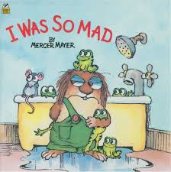
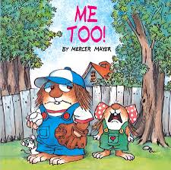

Before reading a book in class we find the front cover, back cover, and title page. We read the title, the author’s name and the illustrator’s name. We review the roles of the author and illustrator. Occasionally during the reading we will pause to ask questions or make predictions. After reading the book we identify the characters and the setting. We may discuss how the character has changed from the beginning of the story.

We clapped and counted syllables in words. It was fun to count syllables in our classmates’ names.

At Jeffery the students will be using an additional math computer program called Dreambox. This can be accessed from the Jeffery homepage under web resources.

In Social Studies we identified rules and procedures that make it possible for home, school, and community to function safely. We talked about rules for different settings (home vs school.) The Social Studies benchmark for first quarter is the expectation that kindergarten students will be able to identify that rules/laws support order and good working relationships and understand that being a good citizen involves acting in certain ways.

In Science we are learning about the needs of plants and animals. We looked at pictures of several animals and discussed their habitat. We learned that the food the animal eats can be found in its habitat. Students will be assuming the role of scientist as they help a group of students from the fictional community of Mariposa Grove. Students in that scenario noticed that there were no more Monarch butterflies in the area since they had turned a nearby field into a community garden. We will examine the problem of the declining Monarch population.

Parent-Teacher conference slips will be sent home on Monday. Please check the date and time for your child’s 15 minute conference and return the bottom portion as soon as possible.

Dates to Remember:
- Tuesday, October 16th
Kindergarten Field Trip to
Borzynski’s Farm & Floral Market

- Friday, October 19th
Fall Fest 5:30-8:00 pm

- Tuesday, October 23
Picture retake day

- Wed-Fri, October 24th-26th
Parent-Teacher Conferences

**See other side for Calendar of Events**

Sunday | Monday | Tuesday | Wednesday | Thursday | Friday | Saturday
14 | 15 | 16 | 17 | 18 | 19 | 20
 |  | Borzynski  Farm  field trip |  |  | Jeffery PTO  Fall Fest  5:30-8:00 pm
21 | 22 | 23 | 24 | 25 | 26 | 27
 |  | Picture  Retakes | Student hours  7:25-2:25  Parent-Teacher  Conferences  3:10-6:10 pm | Student hours  7:25-11:15 am  Parent-Teacher  Conferences  12:10-3:10 pm  5:00-7:00 pm | (NO school  for students)  Parent-Teacher  Conferences  7:10-9:10 am
28 | 29 | 30 | 31 | Nov 1 | 2 | 3
 |  |  |  | End of  1st Quarter | (NO school  for students)  Staff  Work Day
4 | 5 | 6 | 7 | 8 | 9 | 10
Popcorn &
Spirit Day
(Popcorn 50¢/bag)

11 | 12 | 13 | 14 | 15 | 16 | 17

PALS Assessment

Book Fair

