Language Arts:
We have been reading fairy tales and discussing the characters and setting. We sorted books by fiction/pretend and non-fiction/real life.

We sorted groups of pictures by their beginning sound.

We learned how to label things in our drawings. We put the letters for the sounds we hear.

We learned the high-frequency words
I like my.
We wrote sentences using the words and practiced reading them to a partner.

Math:
We started Unit 2 this week.
We continued building and saying patterns. The work place Unifix Cube Patterns was introduced.

We are learning the terms greater than, less than, and equal. We use these words as we play math games.

Accuracy in counting is a critical skill in math. One-to-one correspondence is an essential benchmark in kindergarten. Students should be able to count 20 objects.

Students should know all five of the following shapes:
Circle, square, triangle, rectangle, hexagon.

Science:
We learned that plants need water. We looked at garlic cloves and put one clove in a cup with water and one clove in a cup with no water. We will observe and record what happens over the next few weeks.

We had fun at the NED assembly. We learned important mindset skills and watched cool yo-yo tricks. NED stands for
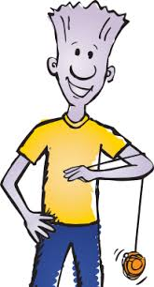

Never give up!
Encourage others!
Do your best!

Dates to Remember:

Wednesday, October 9th
Green Meadows Field Trip

Friday, October 11th
Spirit & Popcorn Day

Friday, October 18th
PTO Fall Fest (5:30-8:00 pm)

Have a wonderful weekend!

We will be taking an all school picture on Monday. Please help your child remember to wear blue on Monday for the picture.

