During the month of January the kindergarten classes will be reading books by author and illustrator Jan Brett. We have been reading different versions of The Gingerbread Man to
compare and contrast. We will continue to read other gingerbread books including The Gingerbread Girl, The Gingerbread Girl Goes Animal Crackers, The Gingerbread Baby, and Gingerbread Friends.
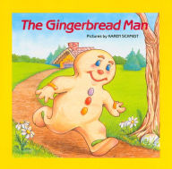
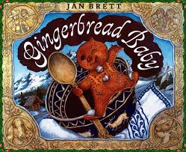

During snack we ate gingerbread cookies. Yum! Then we made a graph to record what part of the gingerbread man we ate first. Most of us ate the head first!

Our high-frequency words were he and she. We learned the spelling pattern –at. We did a ‘word work’ activity to make words that rhyme with /at/.

* * * * * * * * * * * * * * * * *

In math we rolled two dice several times and graphed their sums. We identified and described the shapes circle, square, triangle, rectangle, and hexagon. We talked about the number of sides and corners the shapes have.

In science we talked about forces and interactions – a push and a pull. We pushed on a ball gently and observed the ball roll a short distance. Then we predicted what would happen when a harder push was put on the ball. We saw the ball roll farther and faster. We concluded our experiment by rolling a ball to a friend several times. Next week we will be conducting experiments using marbles and ramps. We will see what happens when one variable is changed. Will the marble roll faster or slower?

* * * * * * * * * * * * * * * * *

If you have not already, please send a class snack for January.

Please read the attached sheet with the Quarter 2 Benchmarks in reading and math.

Have a wonderful weekend!

**See other side for Calendar of Events**

Sunday | Monday | Tuesday | Wednesday | Thursday | Friday | Saturday
1 | 2 | 3 | 4 | 5 | 6 | 7
New Year’s  Day | No School | School  Resumes |  |  | 11:15  Dismissal
8 | 9 | 10 | 11 | 12 | 13 | 14
 |  | PTO meeting  in library  6:00 pm |  |  | Book Order due  Popcorn &  Spirit Day  (Popcorn 50¢/bag)  11:15  Dismissal
15 | 16 | 17 | 18 | 19 | 20 | 21
 | MLK Day  NO School |  |  |  | End of 2nd  Quarter  Staff Work Day
22 | 23 | 24 | 25 | 26 | 27 | 28
29 | 30 | 31 | Feb 1 | 2 | 3 | 4
Kindergarten
Parent
Chat & Chew
5:30 dinner
6:00 program

