During the month of January the kindergarten classes will be reading books by author and illustrator Jan Brett. We have been reading different versions of The Gingerbread Man to
compare and contrast. We will continue to read other gingerbread books including The Gingerbread Girl, The Gingerbread Girl Goes Animal Crackers, The Gingerbread Baby, and Gingerbread Friends.
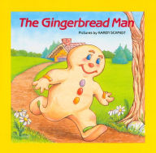
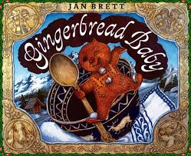

This week’s high-frequency word was play.

We learned the spelling patterns –at and -an. We did a ‘word work’ activity to make words that rhyme with /at/ and /an/.

* * * * * * * * * * * * * * * * *
In math we discussed the terms more/greater than and less/less than. We played the card game Top-It; otherwise known as War. We practiced describing teen numbers as

“a ten and some ones”
Fourteen is a ten and four ones.

We identified and described the shapes circle, square, triangle, rectangle, and hexagon. We talked about the number of sides and corners the shapes have.

* * * * * * * * * * * * * * * * *
In Social Studies we are learning about needs and wants. We talked about jobs that people do and identified if they provided goods or service.

In science we continue to talk about the needs of plants and animals. We’ve discussed the following concepts:

Chapter 1:
1. Different kinds of plants and animals live in different places.
2. An animal needs to eat food to live.
3. Animals can only live in a place that has the food they need.

Chapter 2:
4. When plants grow, they get bigger and have new parts that were not there before.
5. Plants need water from the place where they are in order to live and grow.
6. Animals need water from the place where they are in order to live and grow.
7. Plants get the water they need with their roots from the soil around them.

If you have not already, please send a class snack for January.

Upcoming Events:
January 12 Spirit & Popcorn Day
Book Order Due

January 12-17 PTO Fundraiser

January 15 NO School
January 19 NO School

Have a wonderful weekend!

**See other side for Calendar of Events**

Sunday | Monday | Tuesday | Wednesday | Thursday | Friday | Saturday
7 | 8 | 9 | 10 | 11 | 12 | 13
Popcorn &
Spirit Day
(Popcorn 50¢/bag)

Book Order
due

11:21
Dismissal

14 | 15 | 16 | 17 | 18 | 19 | 20
 | MLK, Jr Day  NO School |  | Fundraiser Money and Forms due |  | Staff Work Day  NO School
21 | 22 | 23 | 24 | 25 | 26 | 27
 | Great American Savings Pass  distributed |  |  |  | 11:21 Dismissal
28 | 29 | 30 | 31 | Feb 1 | 2 | 3
 |  |  |  |  | 11:21 Dismissal
4 | 5 | 6 | 7 | 8 | 9 | 10
Popcorn &
Spirit Day
(Popcorn 50¢/bag)

11:21 Dismissal

PTO Fundraiser: Great American Savings Pass

