During the month of January the kindergarten classes will be reading books by author and illustrator Jan Brett. We read the book The Mitten and talked about the characters and setting. After reading several versions of The Mitten by different authors, we will compare and contrast the stories.
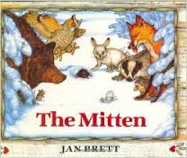

The high-frequency words for this week were how, he, and she. We did a ‘making words’ activity with –an and –at words.

We practiced blending and segmenting words. When given the sounds /s/ /u/ /n/ your child should be able to blend them together to say sun. When given the word run, your child should be able to segment (separate) the word into the sounds /r/ /u/ /n/.

* * * * * * * * * * * * * * * * *
In math we are reviewing the following skills and concepts:

identify flat (2D) and solid (3D) shapes.

compare numbers using the terms greater than/less than.

write numbers to 12 correctly.

understand +1 means ‘add one’ more.

solve addition and subtraction word problems within 5.

In science we learned about the words push, pull, balance, slope, roll, and spin. We are working on a vocabulary packet with these terms. We did an experiment using cardboard shapes to see if we could get them to balance. Then we used clothespins as “counter balances” to see if that would help. We learned that the “counter balances” needed to be positioned just right in order to balance the cardboard shapes. We all agreed it was challenging!

Another experiment we did was using marbles and tracks. We learned that increasing the height of the slope made the marble roll farther and faster! We decided that roller coasters and waterslides were good examples of slopes.

* * * * * * * * * * * * * * * * *

We’ve been researching information about polar bears. We looked at articles, library books, and video clips to gather information which we will use in our writing. Ask your child to tell you what he/she learned about polar bears.

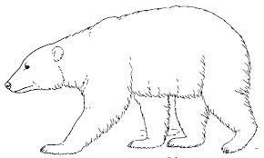

Have a wonderful weekend!

**See other side for Calendar of Events**

Sunday | Monday | Tuesday | Wednesday | Thursday | Friday | Saturday
 | 5 | 6 | 7 | 8 | 9 | 10
 |  |  |  |  | 11:15 Dismissal
11 | 12 | 13 | 14 | 15 | 16 | 17
11:15 Dismissal
* * * * * * *
Snowflake
Ball
11:15-1:30
18 | 19 | 20 | 21 | 22 | 23 | 24
 | MLK, Jr  Day  No school  for students  or staff |  | Scholastic  Book order  due | End of  2nd Quarter | Teacher  Work Day  No school  for students
25 | 26 | 27 | 28 | 29 | 30 | 31
Field trip to
the Golden
Rondelle
Feb 1 | 2 | 3 | 4 | 5 | 6 | 7

