During the next couple of weeks the kindergarten classes will be reading various versions of the story
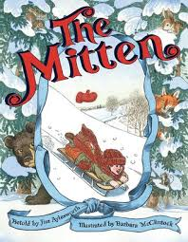
The Mitten. Once
again we will compare
& contrast the
characters, settings,
and events in the
different stories.
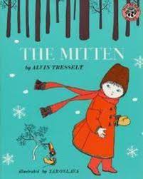

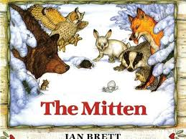

The high-frequency words for this week and next week are he, she, will and be. We practiced blending and segmenting CVC words. These are words that follow the consonant-vowel-consonant pattern. When given the sounds /s/ /u/ /n/ your child should be able to blend them together to say sun. When given the word run, your child should be able to segment (separate) the word into the sounds /r/ /u/ /n/.

We did a word sort using –an and –at words.
Student reading and writing inventories increase as they learn more word families/ spelling patterns.

We continue to work toward our goal of writing three sentences to tell a personal narrative or retell a story with a beginning, middle, and end.

We read about Dr. Martin Luther King, Jr. and talked about ways we can show kindness to others.
In math we used ten frames to review the teen numbers. We practiced this counting skill on ixl.com, skill D. As students work hard to complete skill levels on ixl, they will receive printed certificates to celebrate their growth.

* * * * * * * * * * * * * * * * *

How are you doing on the Six Flags Read to Succeed program? Students who read or are read to for 6 hours and return the reading log will earn a free ticket to Six Flags! Reading logs are due February 22nd.

* * * * * * * * * * * * * * * * *

Upcoming Events:

January 12-17 PTO Fundraiser

January 15 NO School

January 18 Chicken Party!
End of 2nd Quarter

January 19 NO School for students
Staff Work Day

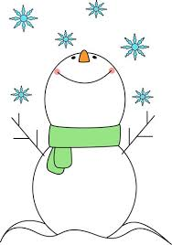
Have a wonderful weekend!

**See other side for Calendar of Events**

Sunday | Monday | Tuesday | Wednesday | Thursday | Friday | Saturday
14 | 15 | 16 | 17 | 18 | 19 | 20
 | MLK, Jr Day  NO School |  | Fundraiser Money and Forms due | Chicken  Party!  End of  2nd Quarter | Staff Work Day  NO School
21 | 22 | 23 | 24 | 25 | 26 | 27
 |  |  |  |  | 11:21 Dismissal
28 | 29 | 30 | 31 | Feb 1 | 2 | 3
 |  |  |  |  | 11:21 Dismissal
4 | 5 | 6 | 7 | 8 | 9 | 10
Popcorn &
Spirit Day
(Popcorn 50¢/bag)

11:21 Dismissal
11 | 12 | 13 | 14 | 15 | 16 | 17
 |  |  | Classroom  Friendship  Party |  | 11:21 Dismissal

