During the month of January the kindergarten classes will be reading books by author and illustrator Jan Brett. We read the book The Mitten and talked about the characters and setting. After reading several versions of The Mitten by different authors, we will compare and contrast the stories.
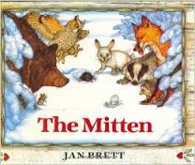

The high-frequency words for this week were how and want. We worked on a book called
I Want to Play Winter Sports.

We practiced blending and segmenting words. When given the sounds /s/ /u/ /n/ your child should be able to blend them together to say sun. When given the word run, your child should be able to segment (separate) the word into the sounds /r/ /u/ /n/.

* * * * * * * * * * * * * * * * *
In math we are reviewing the following skills and concepts:

- identify 5 flat shapes (circle, square, triangle, rectangle, hexagon)

- tell whether a shape is flat (2D) or
solid (3D).

- compare numbers using the terms greater than/less than or equal.

- write numbers to 12 correctly with no reversals.

- understand +1 means ‘add one’ more.
- solve addition and subtraction word problems within 5.

* * * * * * * * * * * * * * * * *

In science we learned about the words push, pull, balance, slope, roll, and spin. We are working on a vocabulary packet with these terms. We did an experiment using marbles and tracks. We learned that increasing the height of the slope made the marble roll farther and faster! We decided that roller coasters and waterslides were good examples of slopes.

* * * * * * * * * * * * * * * * *

We’ve been researching information about polar bears and other Arctic animals. We looked at articles, library books, and video clips to gather information which we will use in our writing.
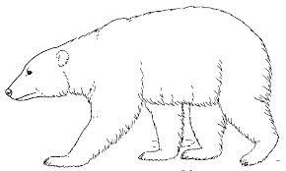

Notes:
- If you have not already, please send a class snack for January.

- Students go outside for recess every day. In order to play in the snow, they must have snow pants and boots. Please be sure your child has a hat and mittens, as well.

Have a wonderful weekend!

**See other side for Calendar of Events**

Sunday | Monday | Tuesday | Wednesday | Thursday | Friday | Saturday
3 | 4 | 5 | 6 | 7 | 8 | 9
 | School  resumes |  |  |  | 11:15 Dismissal
10 | 11 | 12 | 13 | 14 | 15 | 16
 |  | PTO meeting  6:00 pm  in Library |  |  | Spirit &  Popcorn Day  11:15 Dismissal
17 | 18 | 19 | 20 | 21 | 22 | 23
 | MLK, Jr  Day  No school  for students  or staff |  |  | End of  2nd Quarter | Teacher  Work Day  No school  for students
24 | 25 | 26 | 27 | 28 | 29 | 30
31 | Feb 1 | 2 | 3 | 4 | 5 | 6

